Zip Payments

SFRA Integration Guide

**Version <21.1.1>**





Contents

Summary 5

Components Overview 6

Functional Overview 6

Zip Processor 6

Zip Checkout 6

Zip Checkout Experience 6

Zip Payment Method 7

PayFlex Payment Method 7

QuadPay Payment Method 7

Use Cases 7

Checkout with Zip/QuadPay/PayFlex and Handle Zip Checkout Experience Outcomes 7

Checkout with QuadPay and Handle QuadPay Checkout Experience Outcomes 9

Checkout with PayFlex and Handle PayFlex Checkout Experience Outcomes 10

Control Available Zip products via min/max ranges 11

Handle Zip/QuadPay/PayFlex Checkout Experience cancellation. 11

Use tokens for delayed captures, order cancellations and refunds. 11

Checkout with New Zip Account Registration 11

Checkout with Zip Saved Payment method 11

Hook capture, refund and cancel 12

Compatibility 12

Limitations, Constraints 12

Implementation Guide 13

System Extensions 13

Zippay payment 13

QuadPay payment 13

PayFlex payment 13

Payment Processors 13

Payment Methods 14

System Object Type Extensions 15

Services 21

Content Assets 21

Installation 22

Archive Contents 22

Archive Preparation 22

Cartridge Installation 23

Customizations and Extensions 23

Use Back-End Hooks to Capture and Refund Amounts 23

Testing 24

Checkout with Zip Standard Flow as Guest 24

Prerequisites 24

Visit website and Choose Locale 24

Add Product 25

Proceed to Checkout as Guest and Enter Shipping Information 25

Enter Billing Information and Choose Zip as Payment Method 26

View Payment Summary and Continue To Zip 27

Choose a Zip Product 28

Confirm Order with Zip 29

Check Order Confirmation Page 29

Check Confirmation Email 30

Check Order in Business Manager 31

Visit Zip Merchant Dashboard to confirm Order 32

Checkout with Zip standard flow as Customer 33

Prerequisites 33

Visit Website and Choose Locale 33

Add Product 34

Proceed to Checkout as Guest and Enter Shipping Information 34

Enter Billing Information and Choose Zip as Payment Method 35

View Payment Summary and Continue to Zip 36

Complete Order with Zip 37

Check Order Confirmation Page 38

Check Token in My Account 38

Checkout with an Existing Customer Token 39

Prerequisites 39

Complete billing step and Pay with Zip 39

Check Order Summary and Place Order 40

Check Order Confirmation 41

Checkout with QuadPay Standard Flow 42

Prerequisites 42

Visit website and Choose Locale 42

Add Product 43

Proceed to Checkout and Enter Shipping Information 44

Enter Billing Information and Choose QuadPay as Payment Method 45

View Payment Summary and Continue to QuadPay 45

Check Order Confirmation Page 49

Check Confirmation Email 50

Check Order in Business Manager 51

Visit Zip Merchant Dashboard to confirm Order 52

Checkout with PayFlex Standard Flow 52

Prerequisites 52

Visit website and Choose Locale 53

Add Product 53

Proceed to Checkout and Enter Shipping Information 54

Enter Billing Information and Choose PayFlex as Payment Method 55

View Payment Summary and Continue to PayFlex 56

Check Order Confirmation Page 59

Check Confirmation Email 60

Check Order in Business Manager 61

Operations, Maintenance 63

Data Storage 63

Zip Tokens 63

Availability 63

Support 63

User Guide 64

Business Manager 64

Configure Zip Payments Processor 64

Configure Zip Payment Method 65

Configure PayFlex Payment Method 65

Configure QuadPay Payment Method 65

Configure Zip Checkout 66

Configure Zip API Client 66

Known Issues 67

Release History 68

# Summary

**Zippay SFRA** cartridge is a cartridge built for SFRA-based sites which allows customers to select Zip payment methods – Zip, QuadPay or PayFlex and place orders using one of many Zip Products.

The integration is based on the SFRA demo store, version 5.1.0. The integration encompasses deployment of the cartridge. There are no further modifications on storefront explicitly required for the cartridge to run.

# Components Overview

## Functional Overview

### Zip Processor

This component is used to handle payments including authorizations, captures and refunds. Zip allows partial captures and partial refunds as well.

### Zip Checkout

This component is used to extend and customize the SFRA checkout with additional features to allow checking out using Zip Checkout Experience.

### Zip Checkout Experience

This component is provided by Zip upon checking out. It can be loaded as a stand-alone page.

The Zip Checkout Experience allows a customer to choose a Zip Product, login with an existing account (or opt for a new one) with that product and attempt to complete checkout.

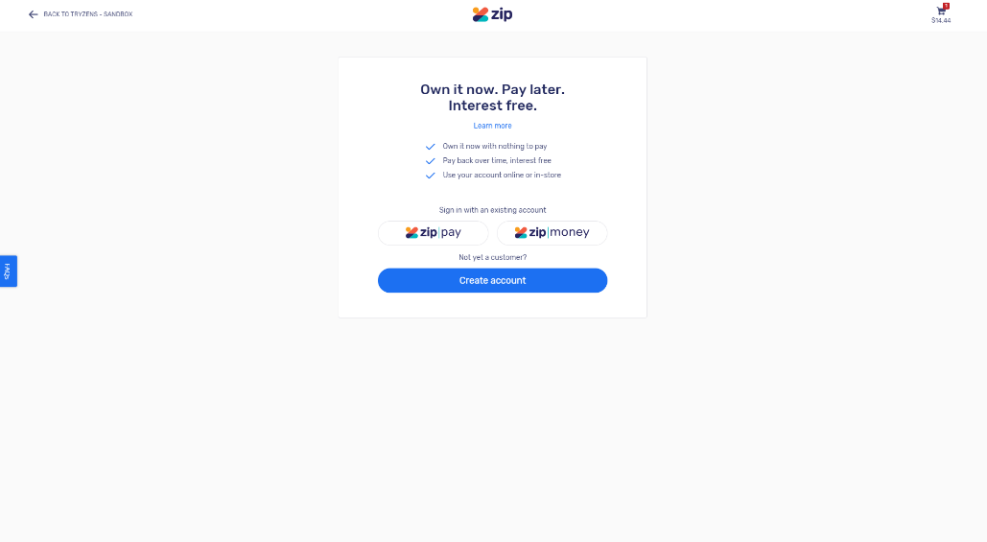

Zip Checkout Experience, Stand-Alone Page

Zip reviews the order and redirect to the merchant’s system with information as to whether the order has been approved or denied.

### Zip Payment Method

This component is used to show Zip as a payment method in checkout and allows customers to choose Zip as a payment method in Australia, New Zealand, United Kingdom regions.

### PayFlex Payment Method

This component is used to show PayFlex as a payment method in checkout and allows customers to choose PayFlex as a payment method in South Africa region.

### QuadPay Payment Method

This component is used to show QuadPay as a payment method in checkout and allows customers to choose QuadPay as a payment method in US region.

## Use Cases

The integration described in this document supports the following features:

* Checkout with Zip/QuadPay/PayFlex and Handle Zip Checkout Experience Outcomes
* Control Available Zip/QuadPay/PayFlex products via min/max ranges.
* Use tokens for delayed captures, order cancellations and refunds.
* Checkout with New Zip/QuadPay/PayFlex Account Registration
* Handle Zip/QuadPay/PayFlex Checkout Experience cancellation.
* Handle Order Denial/Recoverable Errors.
* Checkout with Zip/QuadPay/PayFlex Saved Payment method

This section describes all the features listed above in detail.

### Checkout with Zip/QuadPay/PayFlex and Handle Zip Checkout Experience Outcomes

A customer visiting the merchant’s website may attempt to checkout with one of the available Zip products: Zip Pay or Zip Money by completing an enhanced SFRA checkout. On the payment checkout stage, the customer can select one of available Zip products:

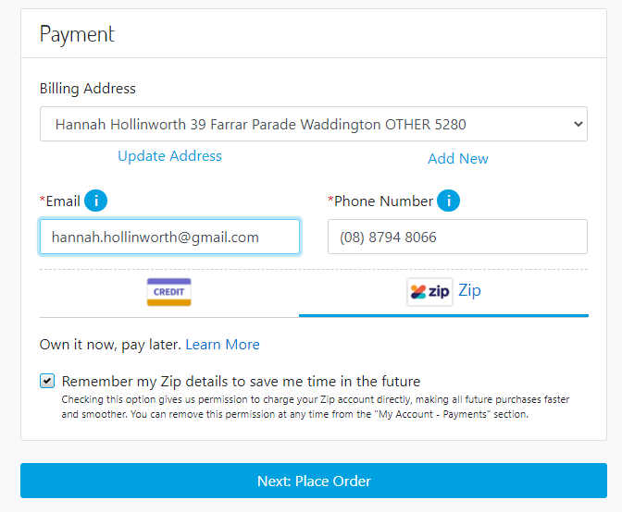

The order review stage has been enhanced with a Zip-specific button “Continue to Zip”, which when clicked will attempt to create and initiate a new Zip Checkout Experience and create a new order within the merchant’s system with status CREATED.

In case of order approval, the integration will attempt to place the order which will change the order’s status to NEW and authorize a new payment by creating a new charge via Zip API.

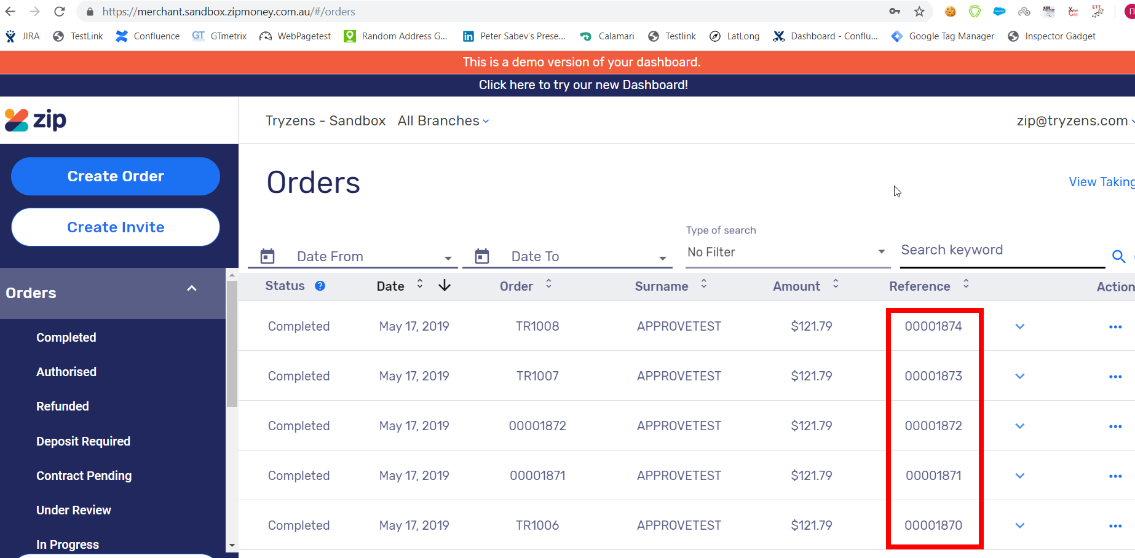

The orders are available in Zip’s merchant dashboard. The “Reference” column holds order numbers generated by the Salesforce platform. The “Order” column holds numbers generated by Zip. The “TR” prefix corresponds to tokenized orders.

If the merchant has enabled automatic capture, the payment amount associated with the newly created charge is also captured. If not, the integration will redirect the customer back to the checkout’s order review stage and show a standard error message. The customer may then attempt to complete a new Zip Checkout as the “Continue to Zip” button is going to be enabled.

### Checkout with QuadPay and Handle QuadPay Checkout Experience Outcomes

A customer visiting the merchant’s website may attempt to checkout with QuadPay by completing an enhanced SFRA checkout. On the payment checkout stage, the customer can select QuadPay:

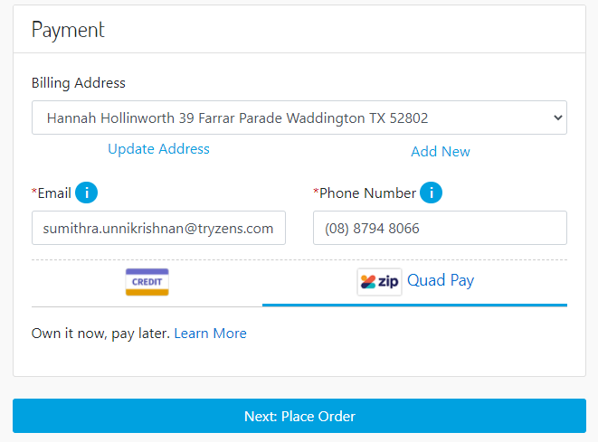

The order review stage has been enhanced with a QuadPay-specific button “Continue to QuadPay”, which when clicked will attempt to create and initiate a new QuadPay Checkout Experience and create a new order within the merchant’s system with status CREATED.

In case of order approval, the integration will attempt to place the order which will change the order’s status to NEW and authorize a new payment by creating a new charge via Zip API.

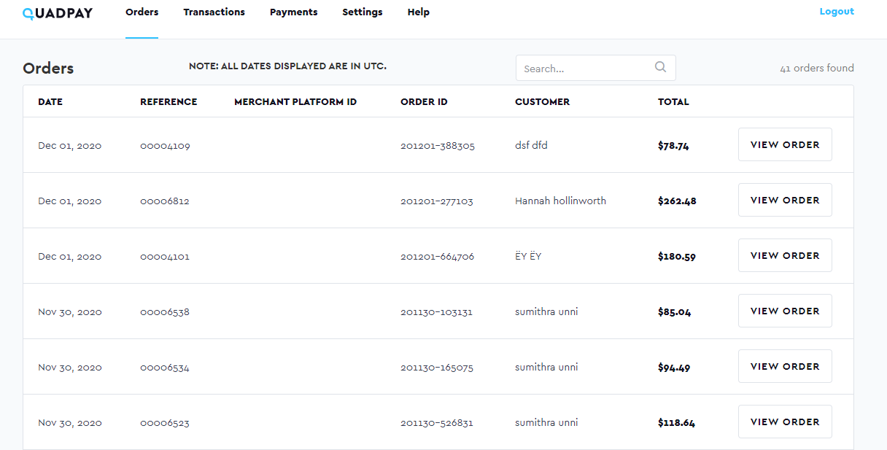

The orders are available in QuadPay’s merchant dashboard. The “Reference” column holds order numbers generated by the Salesforce platform. The “Order ID” column holds numbers generated by QuadPay.

If the merchant has enabled automatic capture, the payment amount associated with the newly created charge is also captured. If not, the integration will redirect the customer back to the checkout’s order review stage and show a standard error message. The customer may then attempt to complete a new QuadPay Checkout as the “Continue to QuadPay” button is going to be enabled.

### Checkout with PayFlex and Handle PayFlex Checkout Experience Outcomes

A customer visiting the merchant’s website may attempt to checkout with PayFlex by completing an enhanced SFRA checkout. On the payment checkout stage, the customer can select PayFlex:

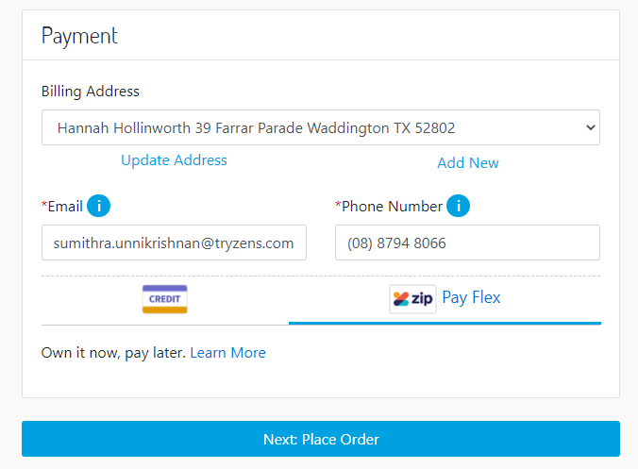

The order review stage has been enhanced with a PayFlex specific button “Continue to PayFlex”, which when clicked will attempt to create and initiate a new PayFlex Checkout Experience and create a new order within the merchant’s system with status CREATED.

In case of order approval, the integration will attempt to place the order which will change the order’s status to NEW and authorize a new payment by creating a new charge via Zip API.

### Control Available Zip products via min/max ranges

The merchant can control Zip applicability via per-currency min/max range.

### Handle Zip/QuadPay/PayFlex Checkout Experience cancellation.

A customer can cancel the Zip/QuadPay/PayFlex Checkout Experience by clicking a link within. The customer is redirected back to the SFRA checkout’s order review stage. Either way, the customer can attempt a new Zip Checkout Experience on the same page.

### Use tokens for delayed captures, order cancellations and refunds.

The merchant can activate tokenization which allows the system to keep a token within a successfully created order. Later, charges can be created, and payment amounts may be captured or refunded without customer’s involvement using the order’s token. Note that the created token does not expire.

The basic checkout creates a new checkout experience which later, when handling checkout completion/cancellation redirect, is used to create charges. This “checkout with tokenization” is a type of checkout which uses a token to create charges. The token is available for further captures and refunds for an order. The merchant can activate tokenization for each one of the Zip products to allow this payment flow.

### Checkout with New Zip Account Registration

A customer’s registration request may be approved within the same customer session (in a matter of seconds) or, it may require a manual approval. In case of manual approval, a Zip Agent will review the registration request and either approve or deny it. If the request has been approved, an email is sent to the customer with a link to finish the checkout process.

### Checkout with Zip Saved Payment method

This use case is applicable only for logged in customers. An additional checkbox is available when a Zip payment method is selected “Save payment method for future use”. The customer continues with checkout as usual. If the order is approved because of completing the Zip checkout experience, a new token is going to be requested via the ZIP API and saved to the customer’s profile.

Later, the token is used anytime the customer attempts to place an order, bypassing the need for a new Zip checkout experience altogether. On the final checkout stage, the button will read “Place Order”.

The token will be available in “My Profile” section where customers can remove the token should they want to discontinue using it. This functionality is only applicable for Zip in AU region.

### Hook capture, refund and cancel

Merchant can programmatically hook to capture, refund and cancel charge. To do that, the merchant needs to disable automatic capture. When automatic capture is disabled, the charges are just authorized. Later, the merchant can use the hooks to trigger multiple captures of a single charge (partial capturing), refunds and charge cancellation.

## Compatibility

Available since Commerce Cloud Platform Release 19.10, SFRA 5.1.0. The cartridge was tested against compatibility mode 19.10.

## Limitations, Constraints

Multi-shipping orders are not supported.

# Implementation Guide

## System Extensions

### Zippay payment

If you are installing the Zip payment method, install the meta files within metadata/site-template_Zip

### QuadPay payment

For QuadPay payment, install meta files within metadata/site-template_QuadPay

### PayFlex payment

For PayFlex payment method, install meta files within the metadata/site-template_PayFlex

### Payment Processors

The system has been extended with a new payment processor: **Zip.**

**Settings are accessible here: “**Merchant Tools – Ordering – Payment Processors – Zip – Settings**”.**

These settings are used for Zip/QuadPay/PayFlex payment method.

|  |  |  |
| --- | --- | --- |
| **Setting** | **Value** | **Description** |
| Zip API Mode Production  (zipApiMode) | Yes/No | If set to yes, the Zip API Client will load the Zip Production Service Profile. If no, Zip API Client will load the Zip Sandbox Service Profile. |
| Zip Tokenization  (zipTokenization) | Yes/No | Enable/disable tokenization for this processor.  Default: No |
| Zip API Key  (zipApiKey) | String | API Key for this payment processor. |
| Automatic Capture  (zipAutoCapture) | Yes/No | Enable/disable automatic captures of charges for this processor.  Default: Yes |
| Enable Zip  (enableZippay) | Yes/No | Enable/disable Zip |

These settings are used for QuadPay payment method.

|  |  |  |
| --- | --- | --- |
| **Setting** | **Value** | **Description** |
| QuadPay API Mode Production  (zipApiMode) | Yes/No | If set to yes, the Zip API Client will load the Zip Production Service Profile. If no, Zip API Client will load the Zip Sandbox Service Profile. |
| Zip Tokenization  (zipTokenization) | Yes/No | Enable/disable tokenization for this processor.  Default: No |
| QuadPay API Key  (zipApiKey) | String | API Key for this payment processor. |
| Automatic Capture  (zipAutoCapture) | Yes/No | Enable/disable automatic captures of charges for this processor.  Default: Yes |
| Enable QuadPay  (enableZippay) | Yes/No | Enable/disable QuadPay. |

These settings are used for PayFlex payment method.

|  |  |  |
| --- | --- | --- |
| **Setting** | **Value** | **Description** |
| PayFlex API Mode Production  (zipApiMode) | Yes/No | If set to yes, the Zip API Client will load the Zip Production Service Profile. If no, Zip API Client will load the Zip Sandbox Service Profile. |
| Zip Tokenization  (zipTokenization) | Yes/No | Enable/disable tokenization for this processor.  Default: No |
| PayFlex API Key  (zipApiKey) | String | API Key for this payment processor. |
| Automatic Capture  (zipAutoCapture) | Yes/No | Enable/disable automatic captures of charges for this processor.  Default: Yes |
| Enable PayFlex  (enableZippay) | Yes/No | Enable/disable PayFlex. |

### Payment Methods

Three payment method has been added: **Zip**, **PayFlex**, **QuadPay** linked to the payment processor described in previous section.

Zip payment method

|  |  |  |
| --- | --- | --- |
| **Setting** | **Values** | **Description** |
| Payment Processor | Zip |  |
| Countries | AU, NZ, UK | This payment method is applicable for Australia, New Zealand and United Kingdom by default.  Selected Countries: AU, NZ, UK. |
| Min/Max Payment Ranges |  | The merchant can set a specific range for which Zip is applicable as a payment method. |

PayFlex payment method

|  |  |  |
| --- | --- | --- |
| **Setting** | **Values** | **Description** |
| Payment Processor | Zip |  |
| Countries | ZA | This payment method is applicable for South Africa by default.  Selected Countries: ZA. |
| Min/Max Payment Ranges |  | The merchant can set a specific range for which Zip is applicable as a payment method. |

QuadPay payment method

|  |  |  |
| --- | --- | --- |
| **Setting** | **Values** | **Description** |
| Payment Processor | Zip |  |
| Countries | US | This payment method is applicable for United States by default.  Selected Countries: US. |
| Min/Max Payment Ranges |  | The merchant can set a specific range for which Zip is applicable as a payment method. |

### System Object Type Extensions

#### Site Preferences

Custom preferences have been added to a new “**Zip**” group for Zip payment method. Those preferences apply to the zip integration (they are not per-processor) for Zip payment method.

|  |  |  |
| --- | --- | --- |
| **Preference** | **Data Type** | **Description** |
| Enable Zip  (enableZippay) | Boolean | Enable/disable Zip |
| Zip API Mode Production  (zipApiMode) | Boolean | API Mode Production for Zip |
| Zip Tokenization  (zipTokenization) | Boolean | Enable/disable tokenization for this processor. Only applicable for Zip in AU region |
| Automatic Capture  (zipAutoCapture) | Boolean | Enable/disable automatic captures of charges for this processor |
| Zip API Key  (zipApiKey) | String | API Key for Zip |

Custom preferences have been added to a new “**PayFlex**” group for PayFlex payment method. Those preferences apply to the zip integration (they are not per-processor) for PayFlex payment method.

|  |  |  |
| --- | --- | --- |
| **Preference** | **Data Type** | **Description** |
| Enable PayFlex  (enableZippay) | Boolean | Enable/disable PayFlex |
| PayFlex API Mode Production  (zipApiMode) | Boolean | API Mode Production for PayFlex |
| Zip Tokenization  (zipTokenization) | Boolean | Enable/disable tokenization for this processor. Only applicable for Zip in AU region |
| Automatic Capture  (zipAutoCapture) | Boolean | Enable/disable automatic captures of charges for this processor |
| PayFlex API Key  (zipApiKey) | String | API Key for PayFlex |

Custom preferences have been added to a new “**QuadPay**” group for QuadPay payment method. Those preferences apply to the zip integration (they are not per-processor) for QuadPay payment method.

|  |  |  |
| --- | --- | --- |
| **Preference** | **Data Type** | **Description** |
| Enable QuadPay  (enableZippay) | Boolean | Enable/disable QuadPay |
| QuadPay API Mode Production  (zipApiMode) | Boolean | API Mode Production for QuadPay |
| Zip Tokenization  (zipTokenization) | Boolean | Enable/disable tokenization for this processor. Only applicable for Zip in AU region |
| Automatic Capture  (zipAutoCapture) | Boolean | Enable/disable automatic captures of charges for this processor |
| QuadPay API Key  (zipApiKey) | String | API Key for QuadPay |

#### Customer Payment Instrument

This custom preference is added to a new “**Zip - SFRA**” group for Zip payment method.

*Note: For QuadPay payment method, this custom preference is added to a new “****QuadPay- SFRA****” group and for PayFlex payment method, this custom preference is added to a new “****PayFlex- SFRA****” group*.

|  |  |  |
| --- | --- | --- |
| **ID** | **Data Type** | **Description** |
| Zip Token  (zipToken) | Password | Used when tokenization has been turned on and an order has been approved. Before placing the order, a new token is created and saved in this attribute for the specific order. Later, the token may be used to create charges for this specific order. |

#### Order

This custom preference is added to a new “**Zip - SFRA**” group for Zip payment method.

|  |  |  |
| --- | --- | --- |
| **ID** | **Data Type** | **Description** |
| Zip Token  (zipToken) | Password | Used when tokenization has been turned on and an order has been approved. Before placing the order, a new token is created and saved in this attribute for the specific order. Later, the token may be used to create charges for this specific order. Available only for Zip AU. |
| Zip Require Approval  (zipRequireApproval) | Boolean | Flag to indicate if the Zip order is linked to a customer account which requires approval. Available only for Zip AU. |
| Zip Receipt Number  (ZipReceiptNumber) | String | Holding the Zip receipt number for this order. |
| Zip Captured Amount  (ZipCapturedAmount) | Double | Holding captured amount for a Zip order. |
| Zip Refunded Amount  (ZipRefundedAmount) | Double | Holding refunded amount for a Zip order. |
| Zip Checkout Id  (ZipCheckoutId) | String | Holding Zip Checkout Id related to this order. |

This custom preference is added to a new “**QuadPay- SFRA**” group for QuadPay payment method.

|  |  |  |
| --- | --- | --- |
| **ID** | **Data Type** | **Description** |
| Zip Token  (zipToken) | Password | Used when tokenization has been turned on and an order has been approved. Before placing the order, a new token is created and saved in this attribute for the specific order. Later, the token may be used to create charges for this specific order. Only for Zip AU. |
| Zip Require Approval  (zipRequireApproval) | Boolean | Flag to indicate if the Zip order is linked to a customer account which requires approval. Only for Zip AU. |
| QuadPay Receipt Number  (ZipReceiptNumber) | String | Holding the QuadPay receipt number for this order. |
| QuadPay Captured Amount  (ZipCapturedAmount) | Double | Holding captured amount for a QuadPay order. |
| QuadPay Refunded Amount  (ZipRefundedAmount) | Double | Holding refunded amount for a QuadPay order. |
| QuadPay Checkout Id  (ZipCheckoutId) | String | Holding QuadPay Checkout Id related to this order. |

This custom preference is added to a new “**PayFlex- SFRA**” group for PayFlex payment method.

|  |  |  |
| --- | --- | --- |
| **ID** | **Data Type** | **Description** |
| Zip Token  (zipToken) | Password | Used when tokenization has been turned on and an order has been approved. Before placing the order, a new token is created and saved in this attribute for the specific order. Later, the token may be used to create charges for this specific order. Only for Zip AU. |
| Zip Require Approval  (zipRequireApproval) | Boolean | Flag to indicate if the Zip order is linked to a customer account which requires approval. Only for Zip AU. |
| PayFlex Receipt Number  (ZipReceiptNumber) | String | Holding the PayFlex receipt number for this order. |
| PayFlex Captured Amount  (ZipCapturedAmount) | Double | Holding captured amount for a PayFlex order. |
| PayFlex Refunded Amount  (ZipRefundedAmount) | Double | Holding refunded amount for a PayFlex order. |
| PayFlex Checkout Id  (ZipCheckoutId) | String | Holding PayFlex Checkout Id related to this order. |

#### Order Address

AU, NZ, UK, US and ZA are added as allowed countries in this system object type, so they appear as valid values for selection within the payment method’s configuration settings.

|  |  |  |
| --- | --- | --- |
| **ID** | **Data Type** | **Description** |
| Country (countryCode) |  | Allowed countries for billing address (see the Countries setting within the ZIP Payments payment method).  Values:   |  |  | | --- | --- | | United States | US | | France | FR | | Italy | IT | | Japan | JP | | China | CN | | United Kingdom | GB | | Australia | AU | | New Zealand | NZ | | South Africa | ZA | |

#### Order Payment Instrument

The following custom attributes have been added to a “**Zip**-**SFRA**” attribute group for Zip payment method:

|  |  |  |
| --- | --- | --- |
| **ID** | **Data Type** | **Description** |
| Zip Email  (zipEmail) |  | This field holds the Zip email, which a customer entered when checking out with one of the available Zip payment methods. The field is shown in the order’s payment tab in BM. |
| Zip Phone  (zipPhone) |  | This field holds the Zip phone, which a customer entered when checking out with one of the available Zip payment methods. The field is shown in the order’s payment tab in BM. |

The following custom attributes have been added to a “**QuadPay**-**SFRA**” attribute group for QuadPay payment method:

|  |  |  |
| --- | --- | --- |
| **ID** | **Data Type** | **Description** |
| QuadPay Email  (zipEmail) |  | This field holds the QuadPay email, which a customer entered when checking out with the QuadPay payment method. The field is shown in the order’s payment tab in BM. |
| QuadPay Phone  (zipPhone) |  | This field holds the QuadPay phone, which a customer entered when checking out with the QuadPay payment method. The field is shown in the order’s payment tab in BM. |

The following custom attributes have been added to a “**PayFlex**-**SFRA**” attribute group for PayFlex payment method:

|  |  |  |
| --- | --- | --- |
| **ID** | **Data Type** | **Description** |
| PayFlex Email  (zipEmail) |  | This field holds the PayFlex email, which a customer entered when checking out with the PayFlex payment method. The field is shown in the order’s payment tab in BM. |
| PayFlex Phone  (zipPhone) |  | This field holds the PayFlex phone, which a customer entered when checking out with the PayFlex payment method. The field is shown in the order’s payment tab in BM. |

#### Payment Transaction

The following custom attributes have been added to a “**Zip**-**SFRA**” attribute group for Zip payment method:

|  |  |  |
| --- | --- | --- |
| **ID** | **Data Type** | **Description** |
| Zip Charge Id  (ZipChargeId) | String | Holding Zip Charge ID. |
| Zip Receipt Number (ZipReceiptNumber) | String | Holding the Zip receipt number for this order. |
| Zip Product  (zipProduct) | String | Holding the Zip Product, the customer placed. |
| Is Automatic Capture  (isZipAutoCapture) | Boolean | Holds the state of Auto Capture param in the capture request. |

The following custom attributes have been added to a “**QuadPay**-**SFRA**” attribute group for QuadPay payment method (Applicable in case of QuadPay installation):

|  |  |  |
| --- | --- | --- |
| **ID** | **Data Type** | **Description** |
| QuadPay Charge Id  (ZipChargeId) | String | Holding QuadPay Charge ID. |
| QuadPay Receipt Number (ZipReceiptNumber) | String | Holding the QuadPay receipt number for this order. |
| QuadPay Product  (zipProduct) | String | Holding the QuadPay Product, the customer placed. |
| Is Automatic Capture  (isZipAutoCapture) | Boolean | Holds the state of Auto Capture param in the capture request. |

The following custom attributes have been added to a “**PayFlex**-**SFRA**” attribute group for PayFlex payment method (Applicable in case of PayFlex installation):

|  |  |  |
| --- | --- | --- |
| **ID** | **Data Type** | **Description** |
| PayFlex Charge Id  (ZipChargeId) | String | Holding PayFlex Charge ID. |
| PayFlex Receipt Number (ZipReceiptNumber) | String | Holding the PayFlex receipt number for this order. |
| PayFlex Product  (zipProduct) | String | Holding the PayFlex Product, the customer placed. |
| Is Automatic Capture  (isZipAutoCapture) | Boolean | Holds the state of Auto Capture param in the capture request. |

#### Profile

The following custom attributes have been added to a “**Zip-SFRA**” attribute group for Zip payment method.

*Note: For QuadPay payment method, this custom preference is added to a new “****QuadPay- SFRA****” group and for PayFlex payment method, this custom preference is added to a new “****PayFlex- SFRA****” group*.

|  |  |  |
| --- | --- | --- |
| **ID** | **Data Type** | **Description** |
| Zip Save Token  (zipSaveToken) | Boolean | A flag programmatically set if the customer wants to save a Zip token. Only for Zip AU. |

## Services

An HTTP service has been added: “zip.http.defaultendpoint” with a profile “zip.http.service” and two credentials: “zip.http.credentials.production” and “zip.http.credentials.sandbox” for each API mode respectively.

## Content Assets

Two content assets have been added as part of the cartridge integration.

|  |  |
| --- | --- |
| zip-declined | This message appears when a Zip payment has been declined. |
| zip-referral-error | This message appears when checkout proceed with Zip referral account and the order became under review. |

# Installation

This section describes the contents of the archive you downloaded from Salesforce as well as the way to prepare and install the archive to support payments with Zip.

## Archive Contents

The archive contains the following folders within:

* “build” – contains front-end build tools and configuration scripts. Note that, building the cartridge front-end resources is unnecessary as they have been added to the archive as well.
* “cartridges” – contains the Zip integration cartridges.
* “cartridges/int_zippay_sfra” – contains SFRA code extensions.
* “cartridges/int_zippay” – contains core code extension
* “cartridges/bm_zippay” – contains Business Manager UI BM-related system extensions to help with QA testing and validating delayed payment flows (partial/full refund and capture of charges).
* “documentation” – contains this “SFRAIntegrationGuide.docx” document which describes integration of Zip Payments with the SFRA.
* “metadata” – contains meta-data to be imported when installing the cartridge.

## Archive Preparation

Before following the installation process in this section, please copy-paste the metadata folder in a temporary directory of your choosing. Then, follow these steps to ensure the archive is prepared for site import:

Note: Please choose site-template folder based on the Zip payment method you are implementing

* If you are installing Zip payment, choose folder site-template_Zip
* For QuadPay, choose folder site-template_QuadPay
* For PayFlex, choose folder site-template_PayFlex

1. Within the site-template_Zip/sites, there is a RefArch folder. Rename the folder so its name corresponds to the name of your SFRA site onto which you want the cartridge installed. For example, if you have a site called RefArchGlobal, you must rename the RefArch folder into a new folder called RefArchGlobal in the same directory.
2. Within the site-template/libraries directory, there is the RefArchSharedLibrary folder. Copy-paste the folder into a new one whose name corresponds to the <your-library-id> content library assigned to your site.
3. Then, within the site-template/libraries/<your-library-id> directory, open library.xml file and look to find library-id="RefArchSharedLibrary" at the first opening tag. Replace that with the name of your library <your-library-id>.

Note that if you have more than one sites onto which you want the cartridge installed, you must follow the same steps and just copy-paste the folders.

## Cartridge Installation

Please, make sure the archive contents you received corresponds to the one described in “Archive Contents” and that you have followed the steps in “Archive Preparation” first.

Cartridge installation is done via following the steps laid out in the installation plan shown below:

1. Add currencies (AUD, NZD, GBP for Zip, USD for QuadPay and ZAR for PayFlex).
2. Add Locales (AU, NZ, GB, US, ZA) – the AU, NZ and GB locales need to be configured for Zip, US locale need to be configured for QuadPay and ZA locale need to be configured for PayFlex.
3. Import cartridge metadata via site import – the system integration expert is required to import metadata via “Site Import/Export” section in the business manager. Beforehand, the “sites/RefArch ” folder may need to be renamed or duplicated so configuration is applied to the right site(s), based on SFRA, within the site structure of the merchant’s system.
4. Update cartridge path – for each SFRA-enabled site which is going to support zip payments, the system integration expert needs to prepend zip cartridge name to the cartridge path. In other words, “int_zippay_sfra” and “int_zippay” needs to come before “app_storefront_base” in the path.
5. Update BM cartridge path – Add “int_zippay” and “bm_zippay” to BM cartridge path
6. For QuadPay payment methods, replace bm_zippay\cartridge\bm_extensions.xml and bm_zippay\cartridge\templates\resources\zippaybm.properties with files from bm-changes_QuadPay
7. For PayFlex payment methods, replace bm_zippay\cartridge\bm_extensions.xml and bm_zippay\cartridge\templates\resources\zippaybm.properties with files from bm-changes_PayFlex

## Customizations and Extensions

### Use Back-End Hooks to Capture and Refund Amounts

To implement capture, please use this line of code:

var hooksHelper = require('*/cartridge/scripts/zip/helpers/hooks');

hooksHelper ('zippay.order.processor', 'Capture', orderNo, amount, orderProcess.Capture );

To implement refund, please use this line of code:

var hooksHelper = require('*/cartridge/scripts/zip/helpers/hooks');

hooksHelper ('zippay.order.processor', 'Refund', orderNo, amount, reason, orderProcess.Refund );

# Testing

## Checkout with Zip Standard Flow as Guest

The most basic test is a checkout by a guest user, going through the Zip standard flow. We are going to use the OOB SFRA site “*RefArch*” to complete the test.

### Prerequisites

As a prerequisite to the test, we must enable auto-capture. Check out the screenshot below:

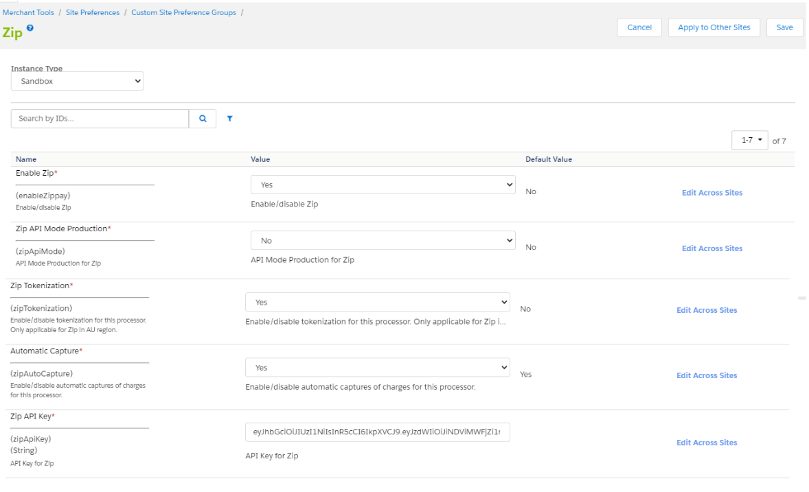

### Visit website and Choose Locale

Once the configuration is done in the Business Manager, you should visit the website. Zip is available for certain countries only. For this test, we are using the “*English (Australia)*” locale from the drop-down.

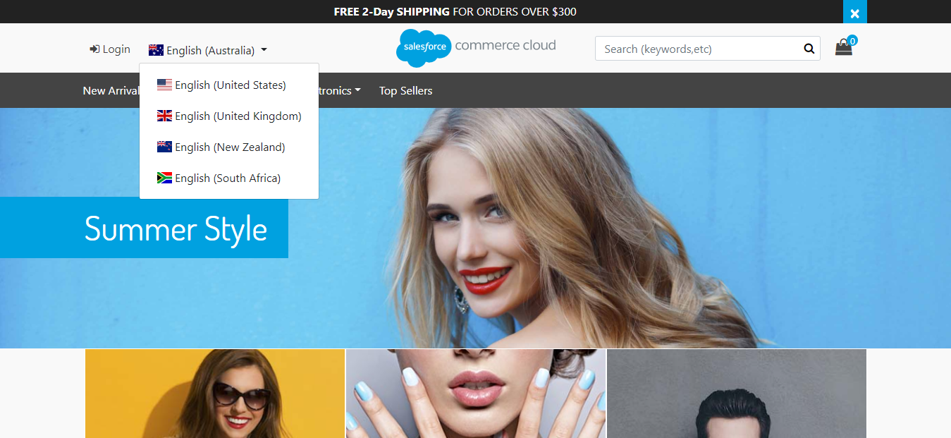

### Add Product

We have selected a simple product from a category “*Mens – Clothing – Suits*”. We have added 1 to cart.

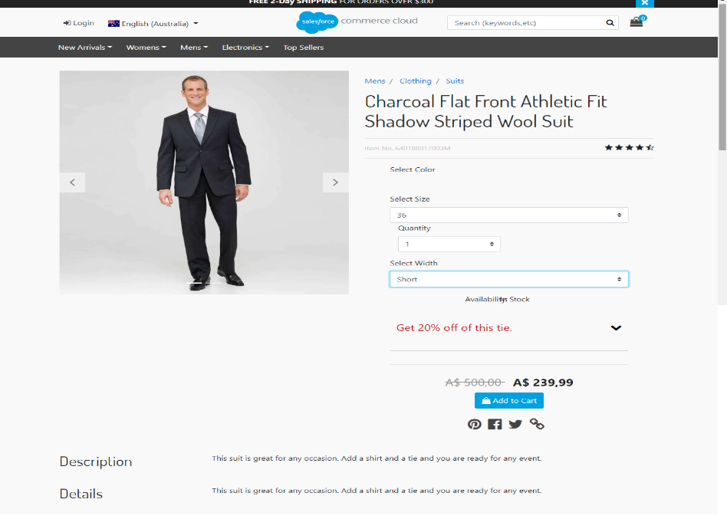

### Proceed to Checkout as Guest and Enter Shipping Information

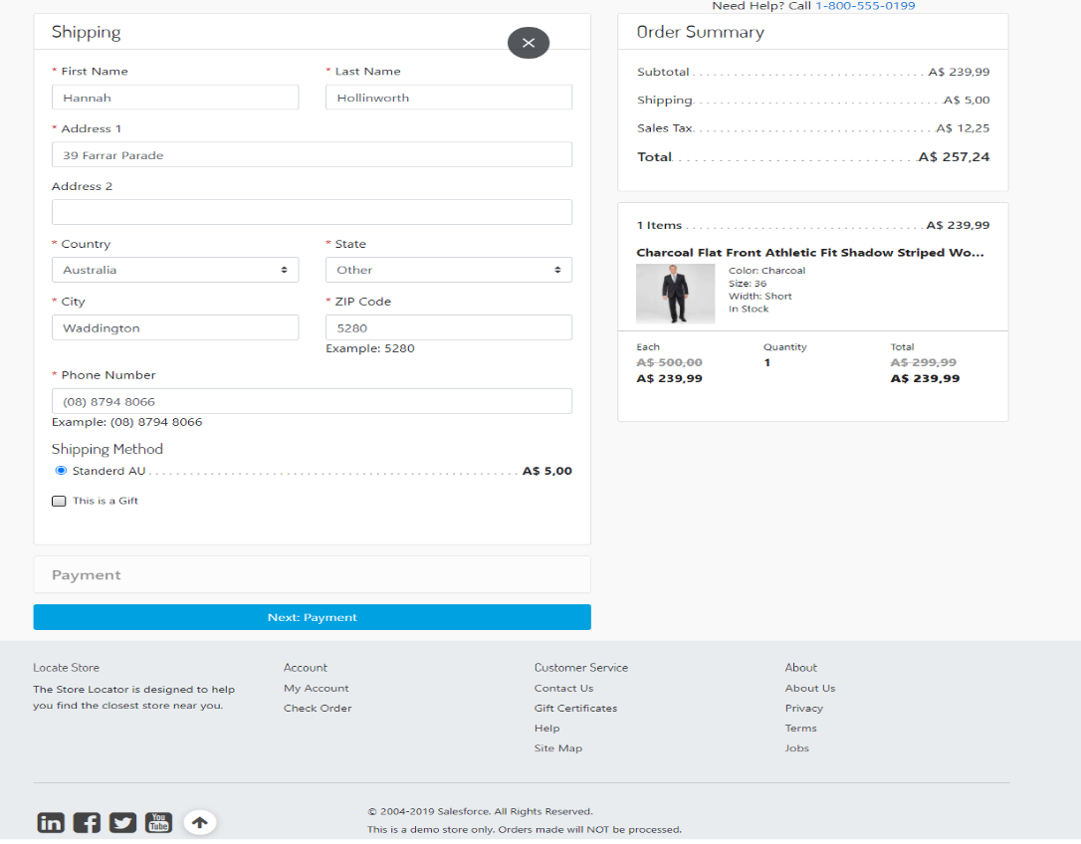

We used the following test address:

|  |  |
| --- | --- |
| First Name | Hannah |
| Last Name | Hollinworth |
| Address 1 | 39 Farrar Parade |
| Country | Australia |
| State | Other |
| City | Waddington |
| Zip Code | 5280 |
| Phone Number | (08) 8794 8066 |

Any shipping method should work. For the test, we are using *Standard AU*.

When done, click “*Next: Payment*”.

### Enter Billing Information and Choose Zip as Payment Method

On the billing step, if everything has been configured correctly, Zip should appear as a payment method.

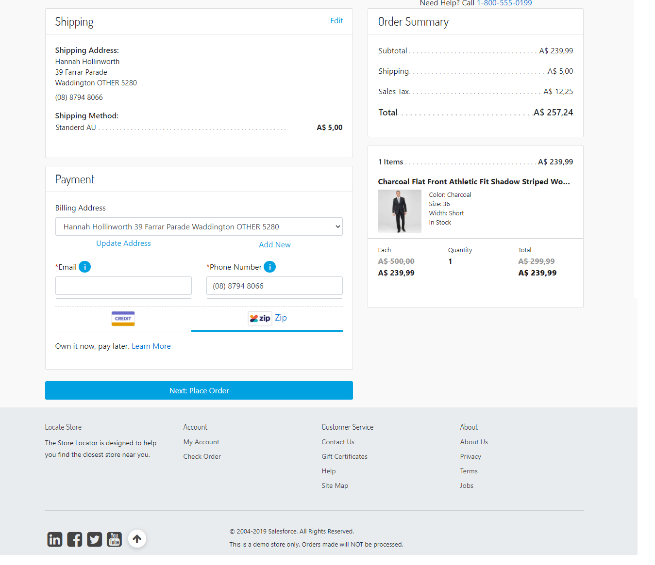

Enter an email and a phone number.

We used the following test phone and email:

|  |  |
| --- | --- |
| Phone Number | (08) 8794 8066 |
| Email | ziptest_12013814330@mailinator.com |

Choose Zip payment method.

Click “*Next: Place Order*”.

### View Payment Summary and Continue To Zip

On the payment summary step, the payment is “Zip” and there should be a button “*Continue To Zip*”.

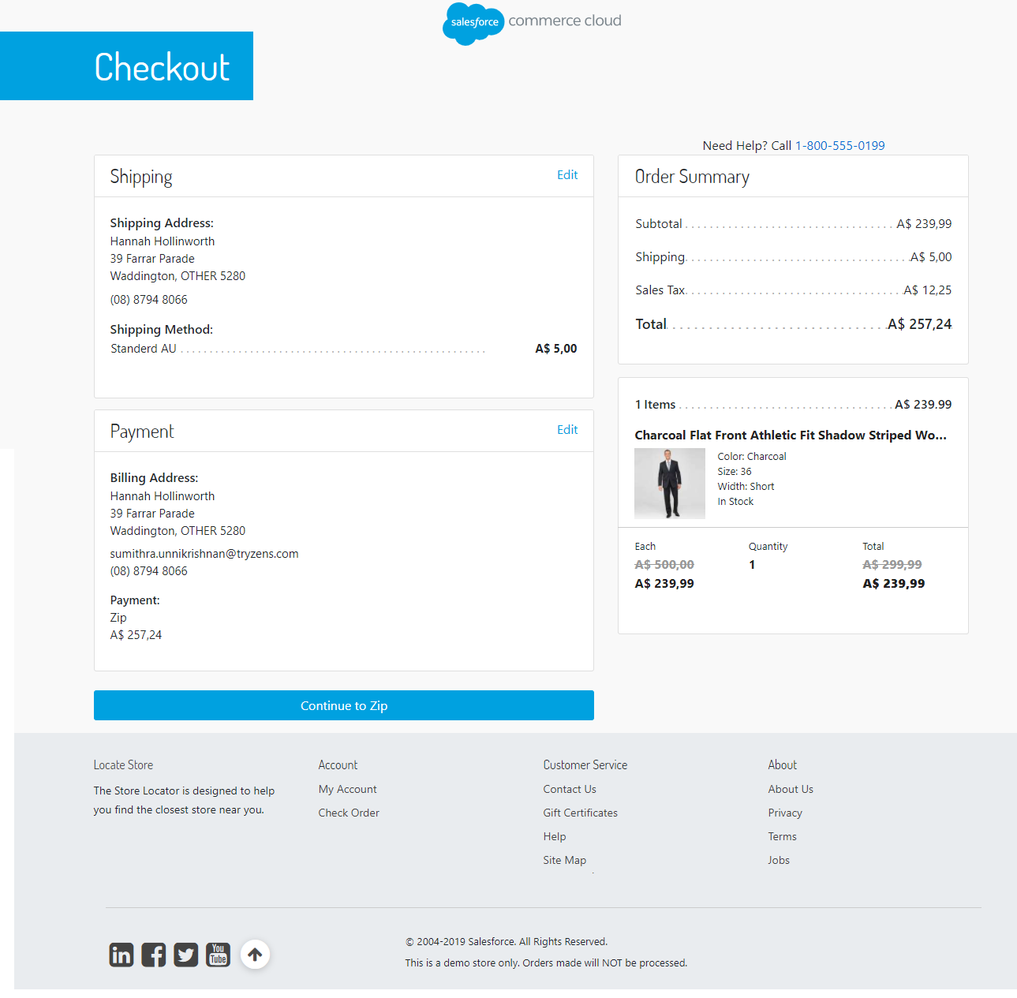

When the button is clicked, you will be redirected to Zip page.

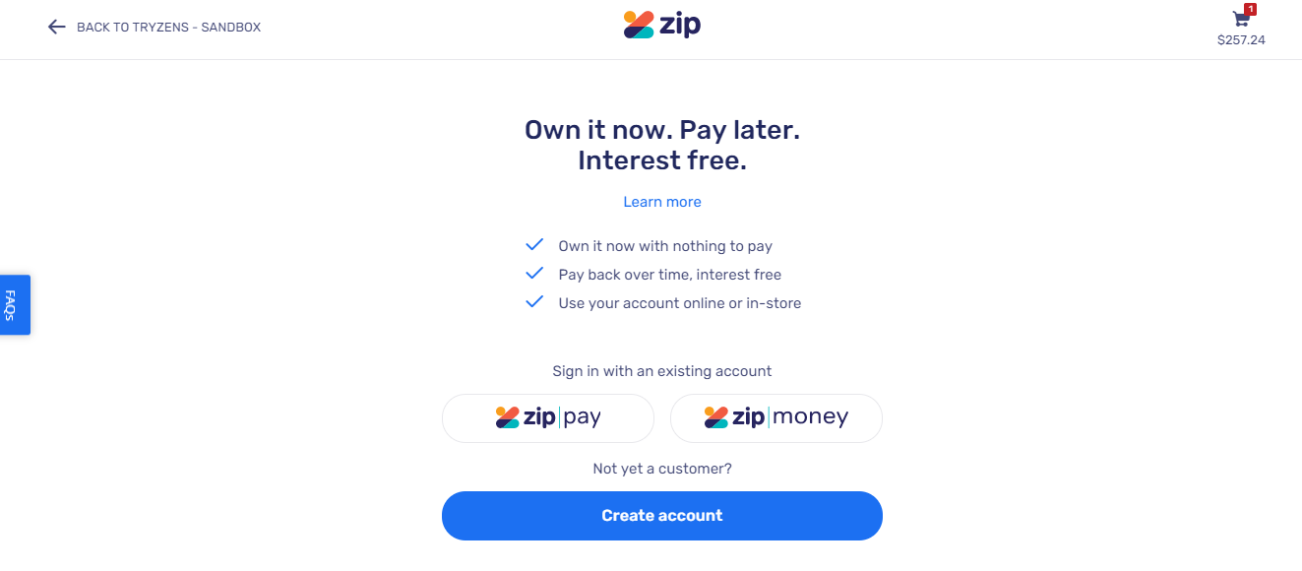

### Choose a Zip Product

Zip currently offers two products: Zip Pay and Zip Money. The first one is used for orders of amounts under 1000$. For bigger orders, Zip Money can be used. In this test, we are going to select Zip Money and use an already existing account to complete the order.

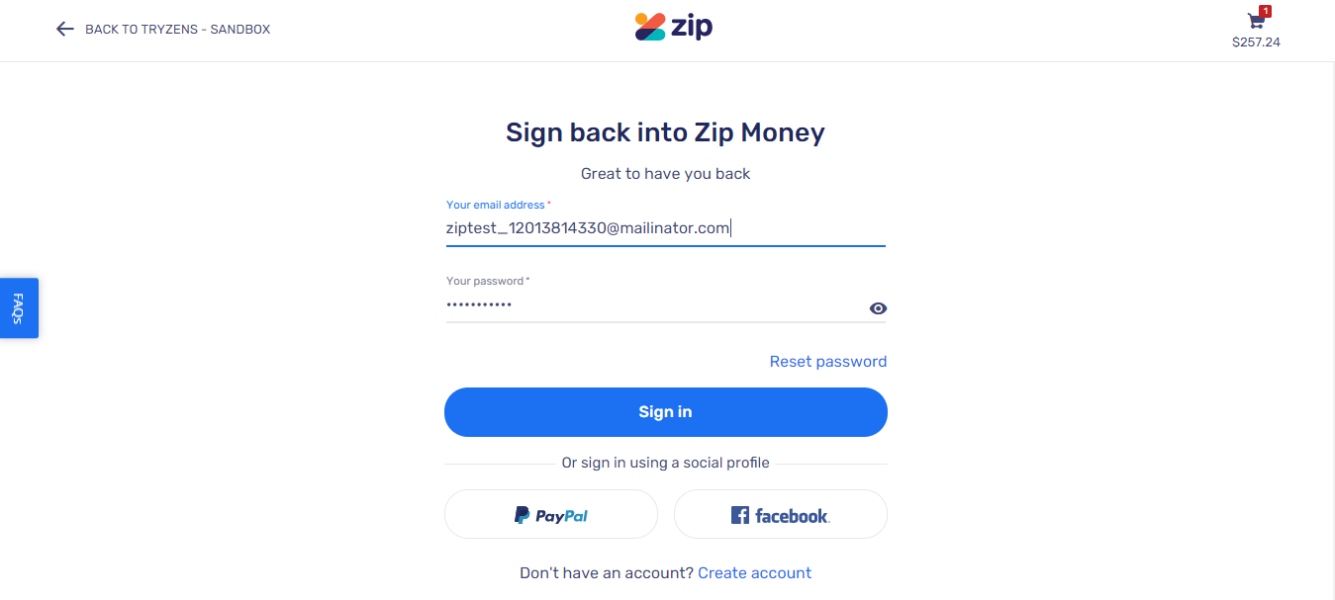

Enter your account credentials and click “*Sign In*”.

### Confirm Order with Zip

Once logged in, you should see payment summary same as the one in the checkout.

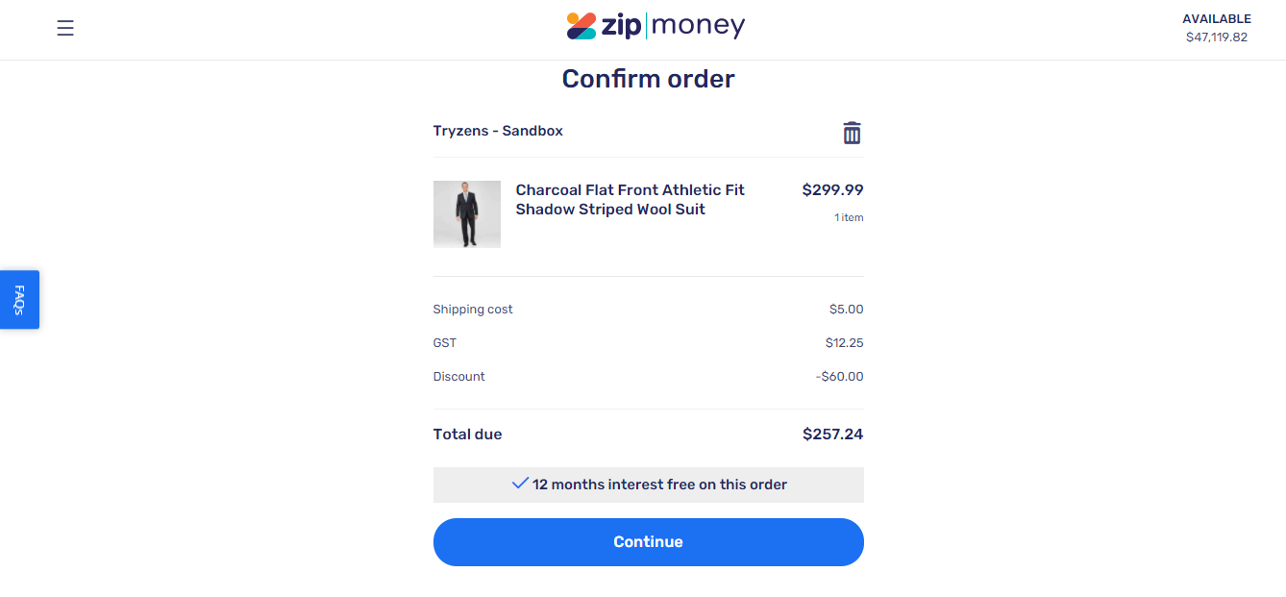

Click “*Continue*”.

### Check Order Confirmation Page

The order has been approved by Zip. You should be redirected back to the “*Thank You*” confirmation page. You should see an additional “*Zip Receipt Number*” which has been generated by Zip. This receipt number is also sent with the confirmation email.

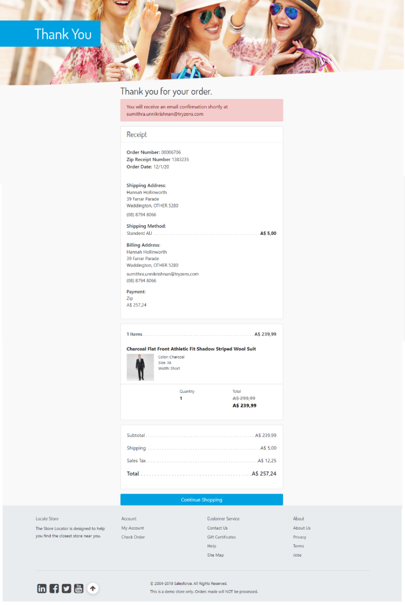

### Check Confirmation Email

The confirmation email sent should also contain Zip Receipt Number as shown below.

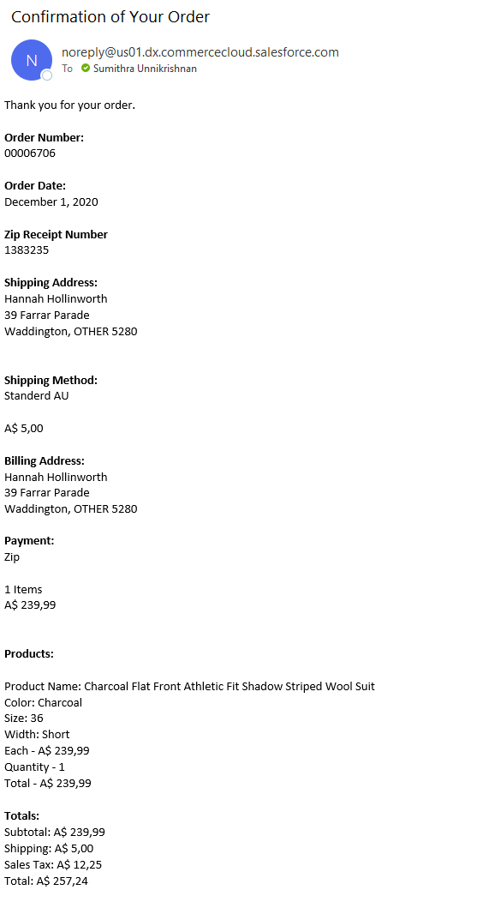

### Check Order in Business Manager

Last, we visit the Order in Business Manager. From “Merchant Tools”, please select “Orders”. Type the order number in the search box and click “Find”.

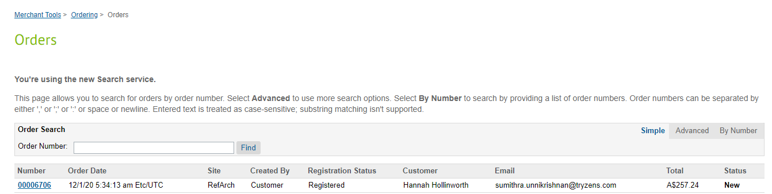

Click on the order number.

The View Order screen appears, and we should be at the “General” tab. Here, you should see status “*Confirmed*” since we have enabled auto-capture in the beginning of the test.

Click on the “*Payment*” tab. There are couple of things we are looking for. Payment status should be “Paid”. The processor for the full payment should be “*Zip*”. In addition to that, Zip Email and Zip Phone contain the email and phone number from billing step during checkout. You should be seeing the Zip Receipt Number same as in the confirmation page and email. The Zip Charge ID is an identifier of the charge created when order has been approved. The “Is Automatic Capture” to confirm the charge has been automatically captured.

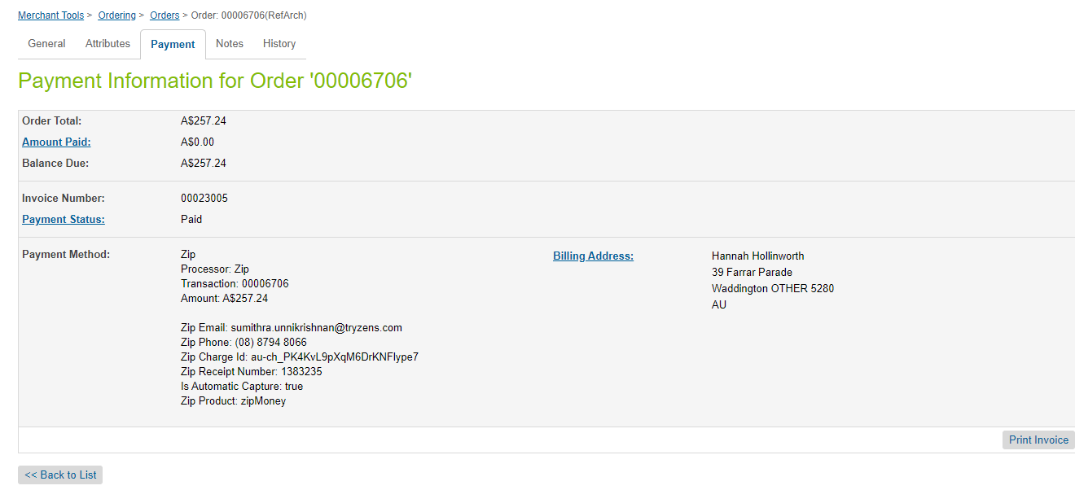

### Visit Zip Merchant Dashboard to confirm Order

As an additional, optional step, we have visited the merchant dashboard to check for the approved order.

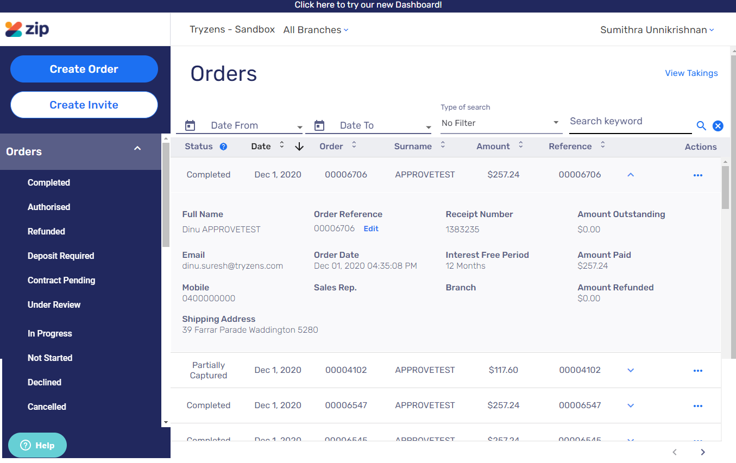

## Checkout with Zip standard flow as Customer

The second test is a successfully completed checkout by a logged in customer who has requested to save Zip as a payment method for future use.

### Prerequisites

For the second test, a prerequisite is to enable tokenization (if not already done) from within the site’s preferences.

Another prerequisite is to have a ready customer account.

### Visit Website and Choose Locale

Once the configuration is done in the Business Manager, you should visit the website. Zip is available for certain countries only. For this test, we are using the “*English (Australia)*” locale from the drop-down.



### Add Product

We have selected a simple product from a category “*Mens – Clothing – Suits*”. We have added 1 to cart.

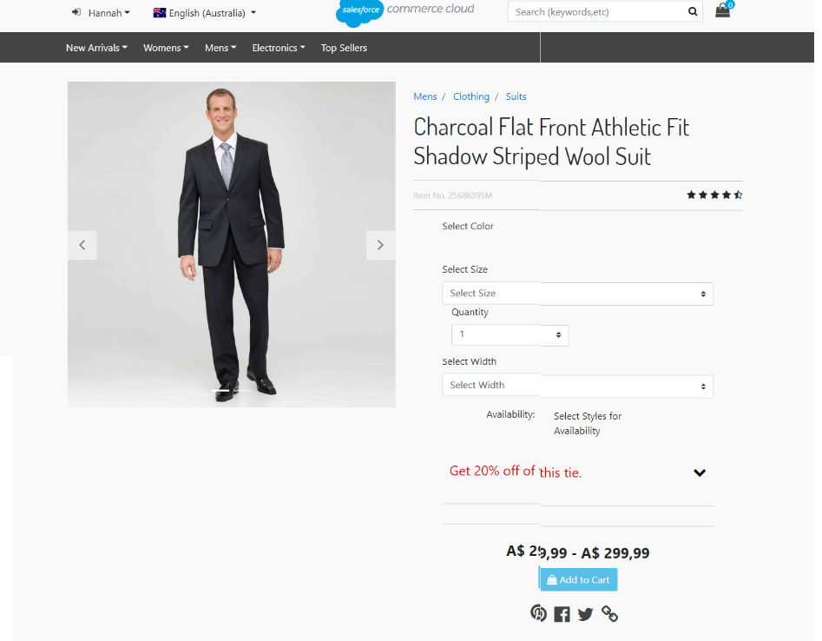

### Proceed to Checkout as Guest and Enter Shipping Information

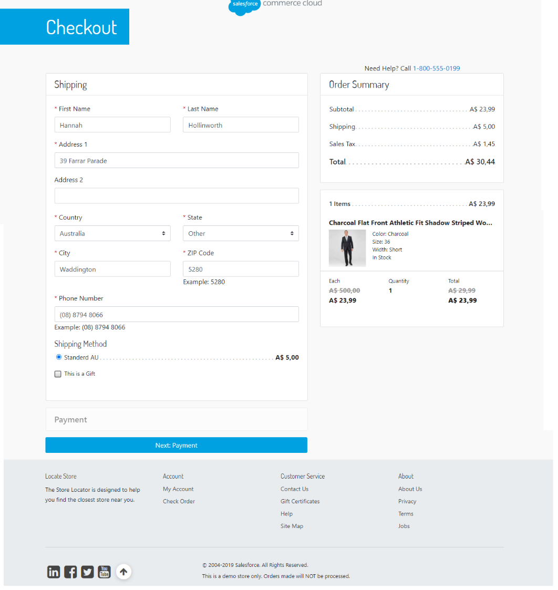

We used the following test address:

|  |  |
| --- | --- |
| First Name | Hannah |
| Last Name | Hollinworth |
| Address 1 | 39 Farrar Parade |
| Country | Australia |
| State | Other |
| City | Waddington |
| Zip Code | 5280 |
| Phone Number | (08) 8794 8066 |

Any shipping method should work. For the test, we are using *Standard AU*.

When done, click “*Next: Payment*”.

### Enter Billing Information and Choose Zip as Payment Method

Enter an email and a phone number.

We used the following test phone and email:

|  |  |
| --- | --- |
| Phone Number | (08) 8794 8066 |
| Email | ziptest_12013814330@mailinator.com |

Choose Zip payment method.

Make sure that you check the “*Remember my Zip details…*” checkbox.

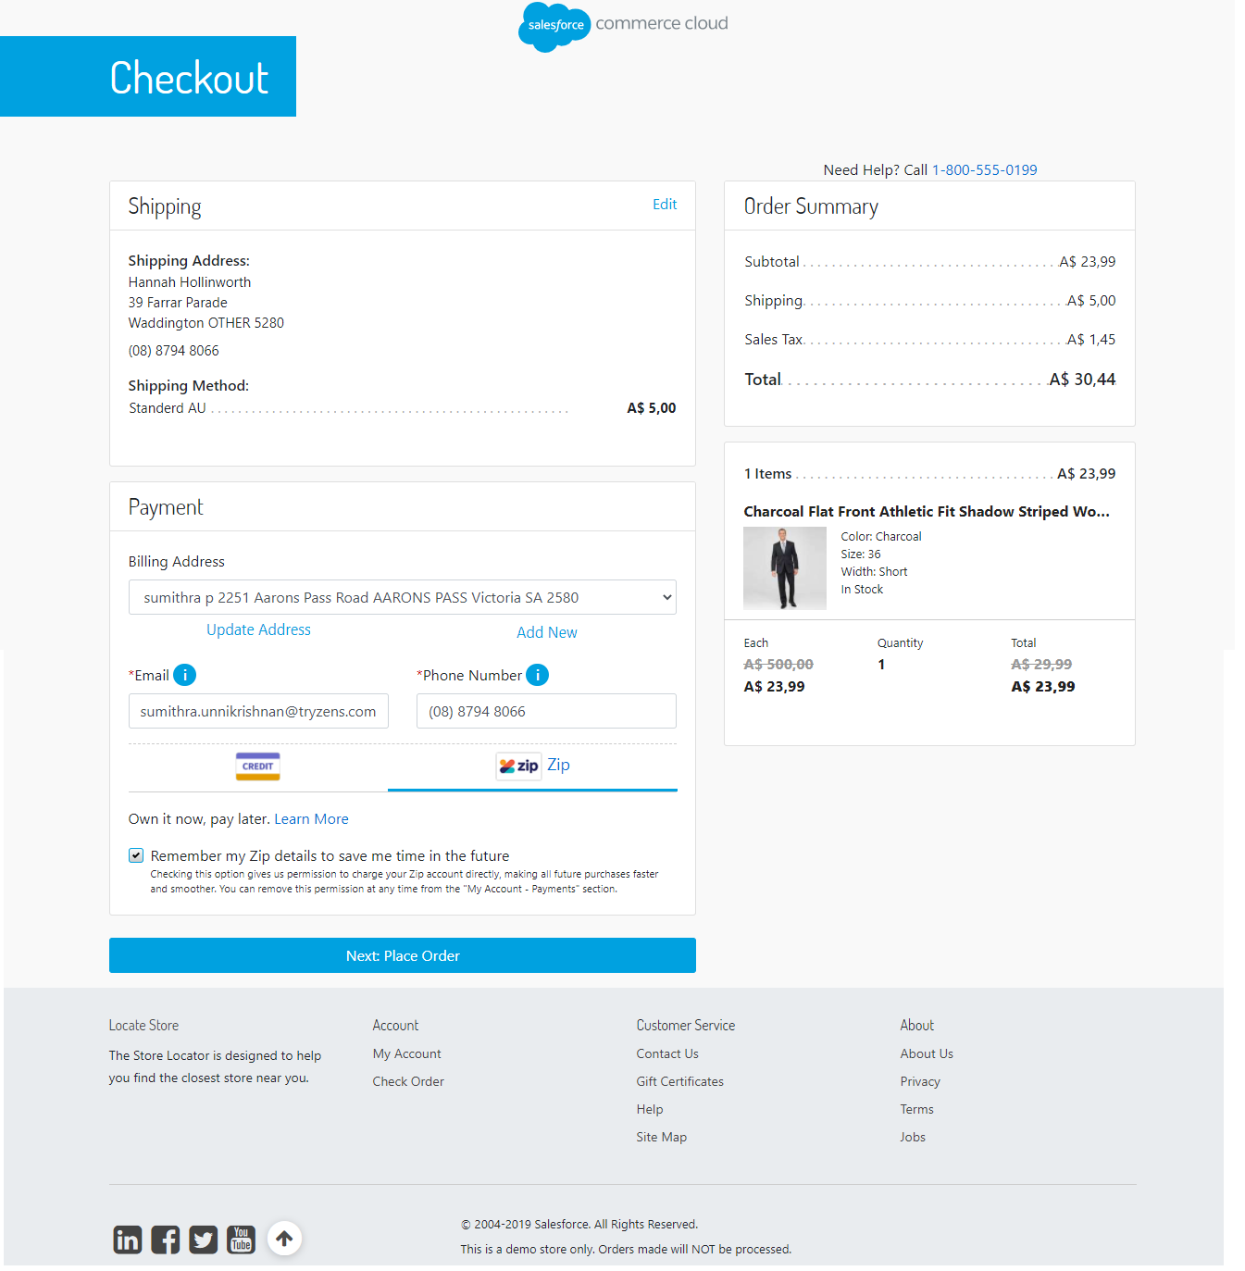

Click “*Next: Place Order*”.

### View Payment Summary and Continue to Zip

On the payment summary step, the payment is “Zip” and there should be a button “*Continue to Zip*”.

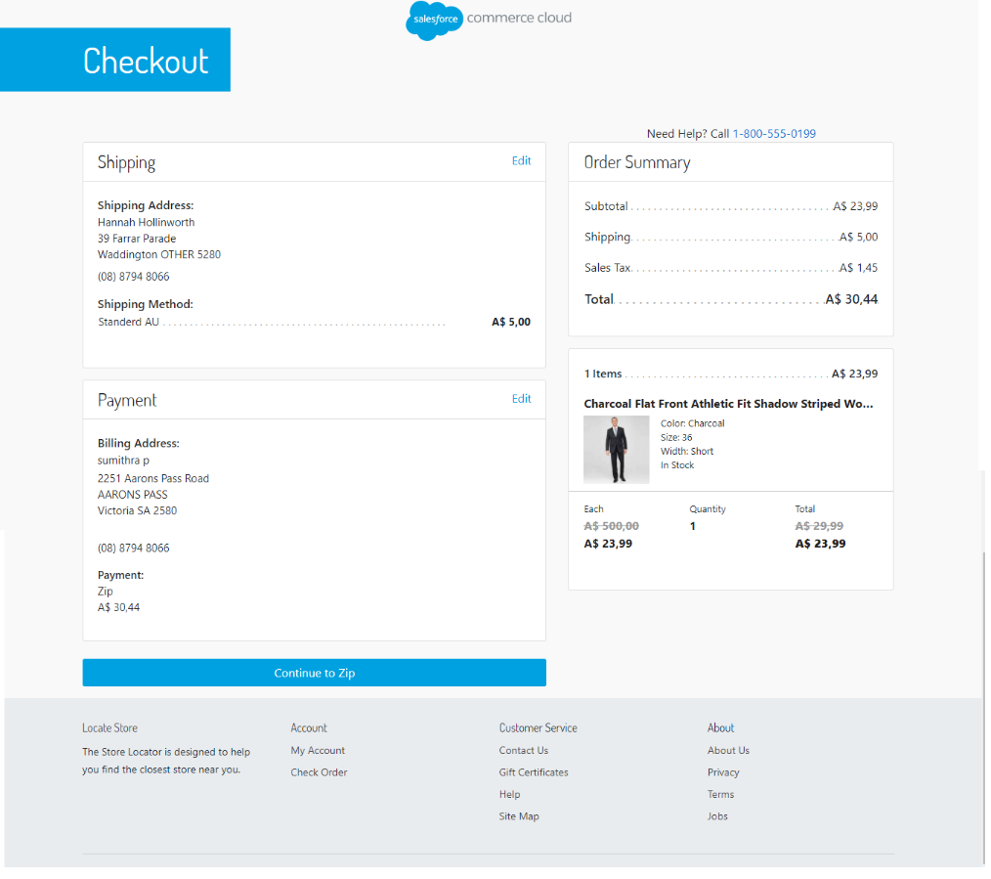

### Complete Order with Zip

As in the first test, we will complete the order with Zip, going through the checkout experience. Once again, we have used Zip Money with a test account. Since we are already logged in Zip, we can just click the “*Continue*” button to confirm the test order.

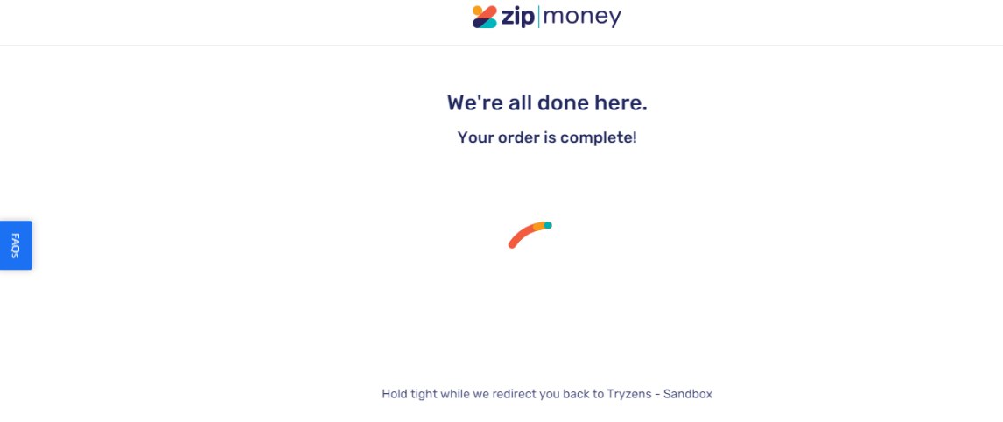

### Check Order Confirmation Page

The order has been approved by Zip. You should be redirected back to the “*Thank You*” confirmation page.

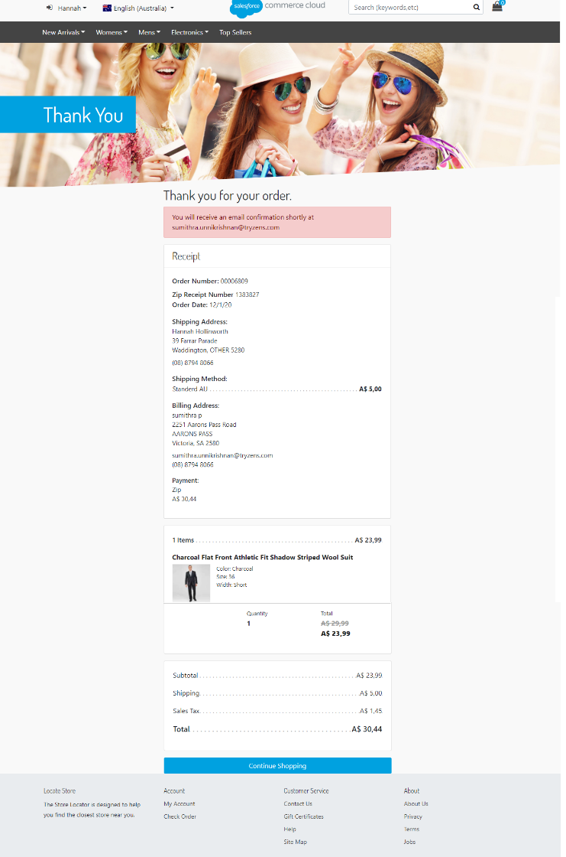

### Check Token in My Account

Navigate to “*My Account*” section on the website.

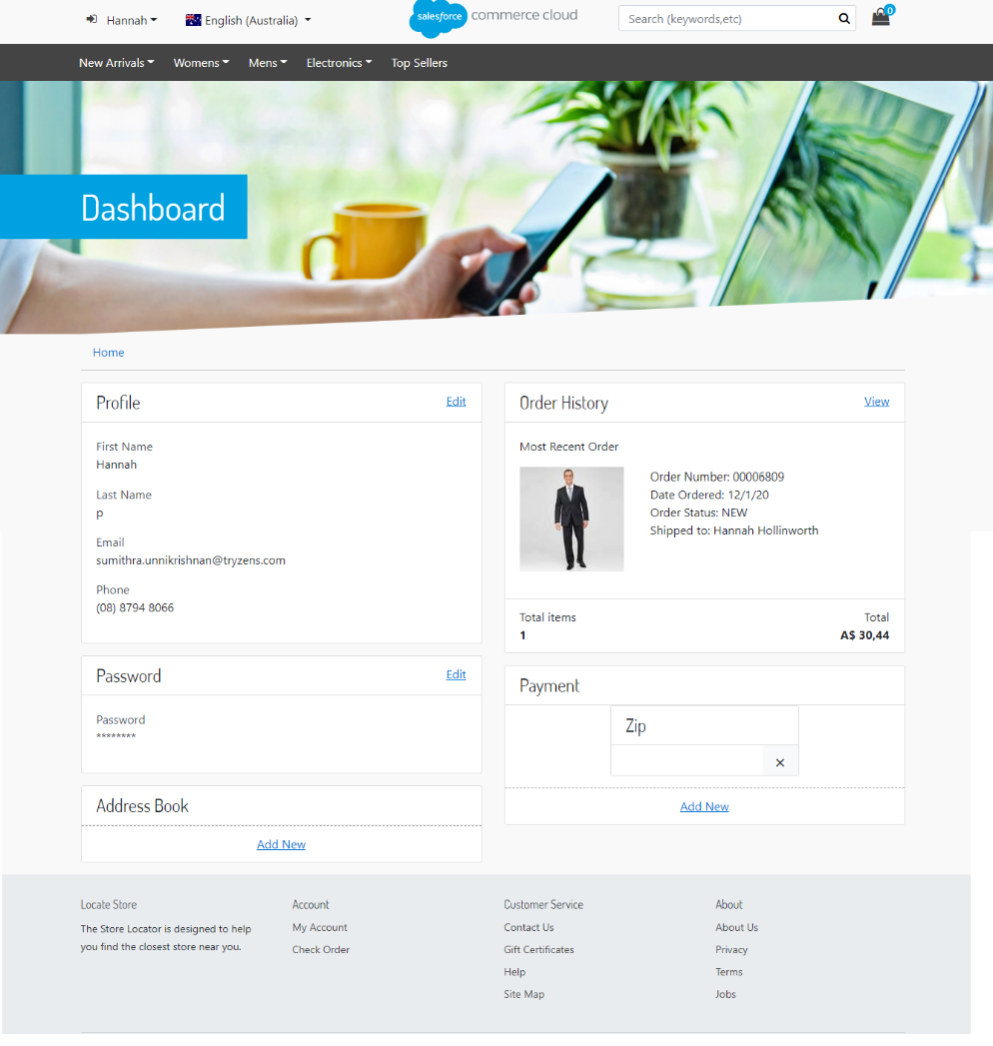

Within the customer’s dashboard, you should be seeing “*Zip*” in the “*Payment*” section.

## Checkout with an Existing Customer Token

The third and final test uses an existing customer token.

### Prerequisites

* An existing customer token, which can be obtained by completing the second test.
* A single product must have been added to cart.
* We are using the same website and locale as in the previous, second test. Those are “*RefArch*” and the “*English (Australia)*” locale.
* In checkout, a valid shipping address must have been added (or selected from customer’s addresses book).

### Complete billing step and Pay with Zip

Once all the prerequisites have been fulfilled, you should be on the billing step.

Enter your email and phone number and choose “*Zip*”.

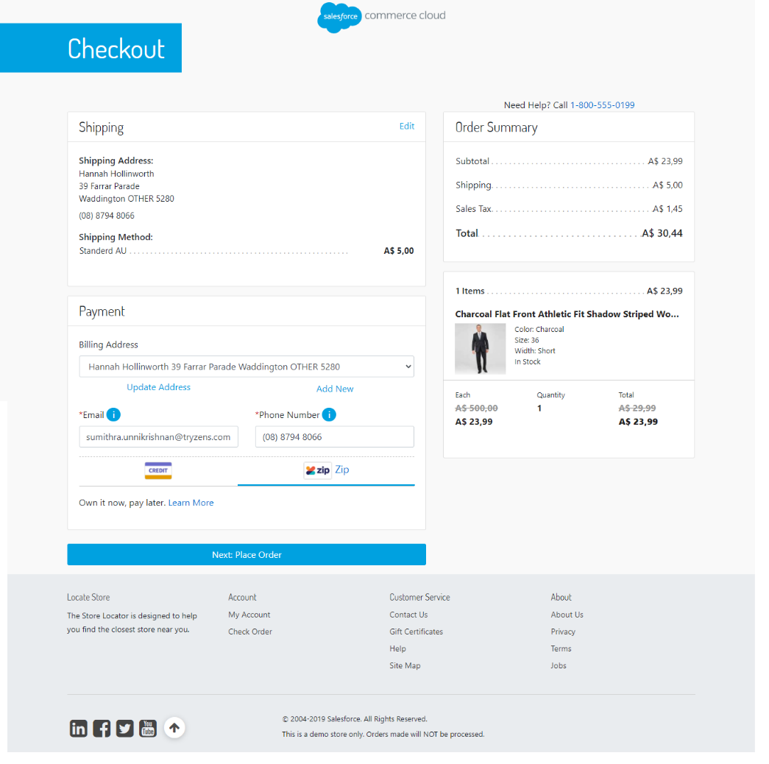

This time, since a token has been already saved in previous test, a checkbox does not appear.

Click “*Next: Place Order*”.

### Check Order Summary and Place Order

The payment summary screen should not show “*Continue to Zip*” button. Instead, “*Place Order*” button is available to quickly place an order using the existing token without going through a new checkout experience.

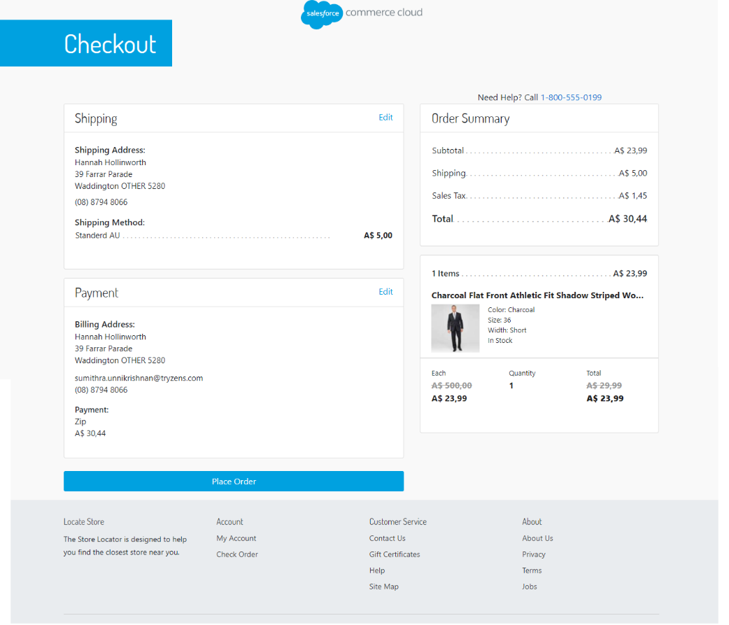

Click “*Place Order*”.

### Check Order Confirmation

You should be redirected straight to the order confirmation screen with a message for a successful order.

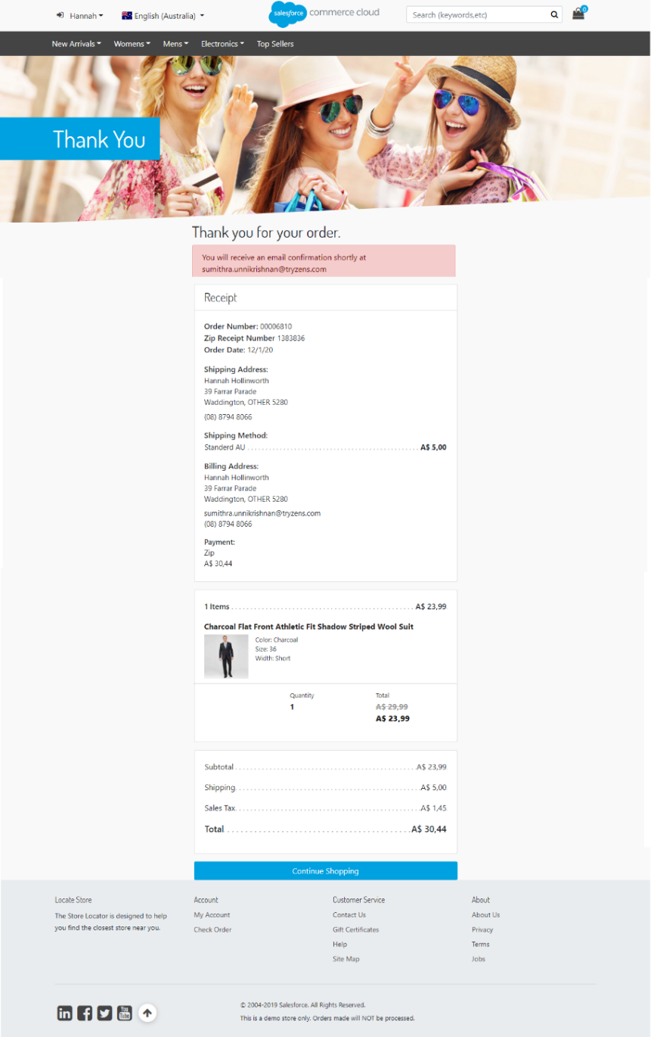

Checkout with QuadPay Standard Flow

We are going to use SFRA OOB site “*RefArch*” to complete the test.

### Prerequisites

As a prerequisite to the test, we must enable auto-capture. Check out the screenshot below:

### Visit website and Choose Locale

Once the configuration is done in the Business Manager, you should visit the website. QuadPay is US region. For this test, we are using the “*English (United States)*” locale from the drop-down.



### Add Product

We have selected a simple product from a category “*Mens – Clothing – Suits*”. We have added 1 to cart.

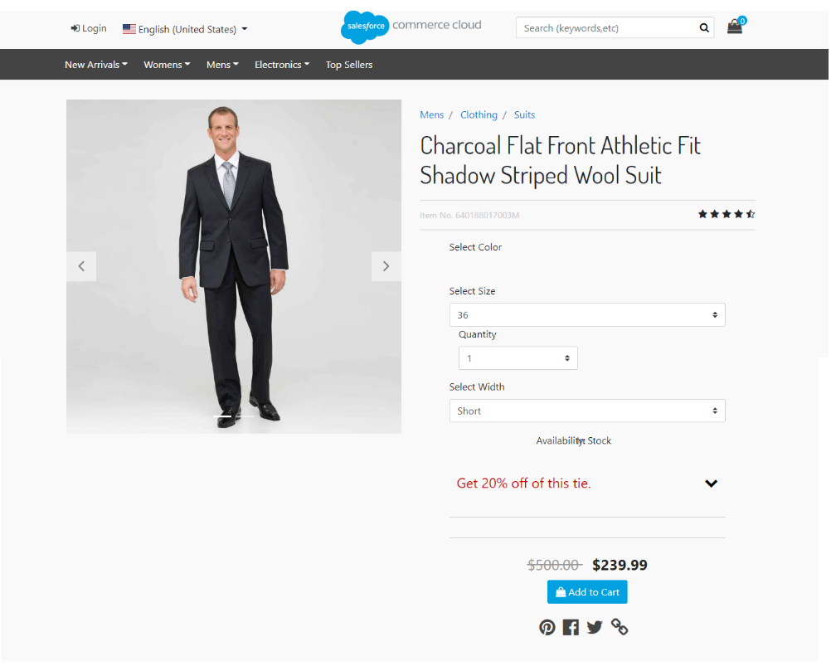

### Proceed to Checkout and Enter Shipping Information

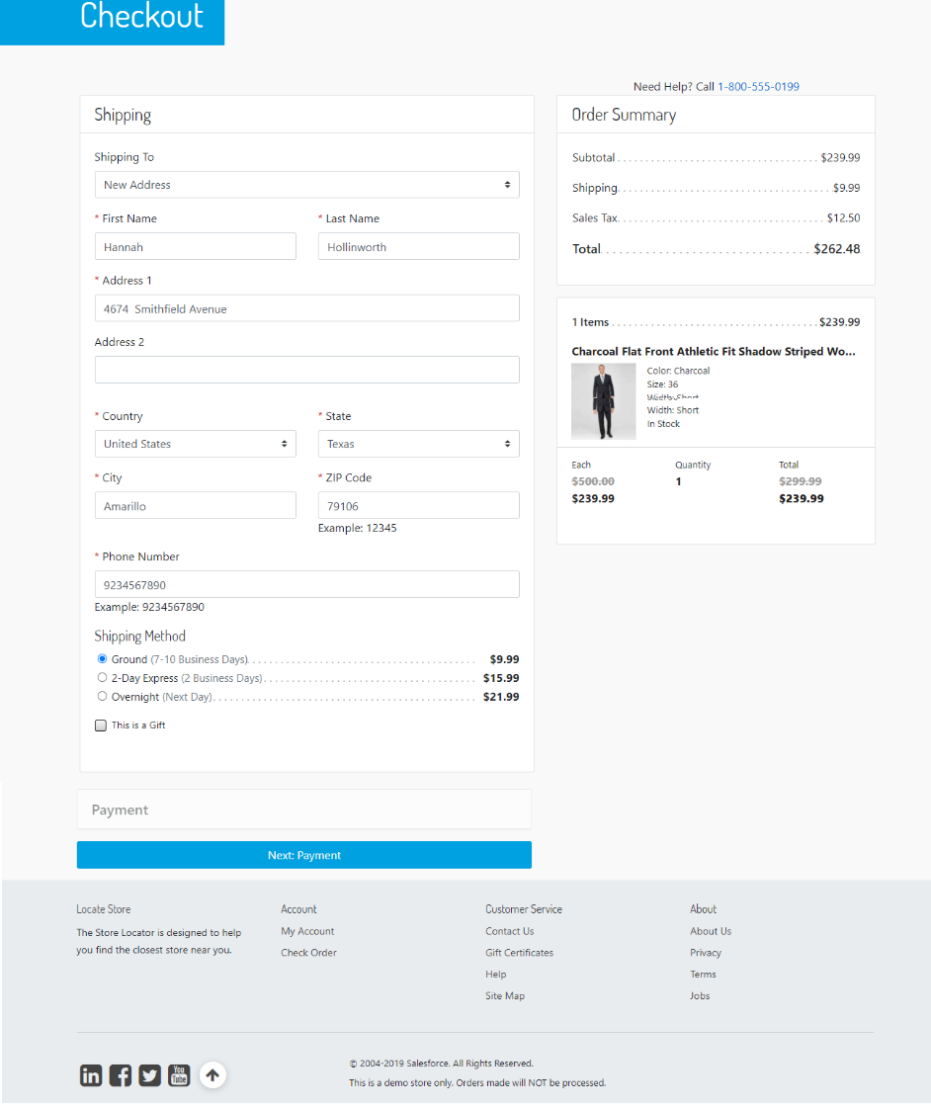

We used the following test address:

|  |  |
| --- | --- |
| First Name | Hannah |
| Last Name | Hollinworth |
| Address 1 | 4674 Smithfield Avenue |
| Country | United States |
| State | Texas |
| City | Amarillo |
| Zip Code | 79106 |
| Phone Number | 9234567890 |

Any shipping method should work. For the test, we are using *Ground*.

When done, click “*Next: Payment*”.

### Enter Billing Information and Choose QuadPay as Payment Method

On the billing step, if everything has been configured correctly, QuadPay should appear as a payment method.

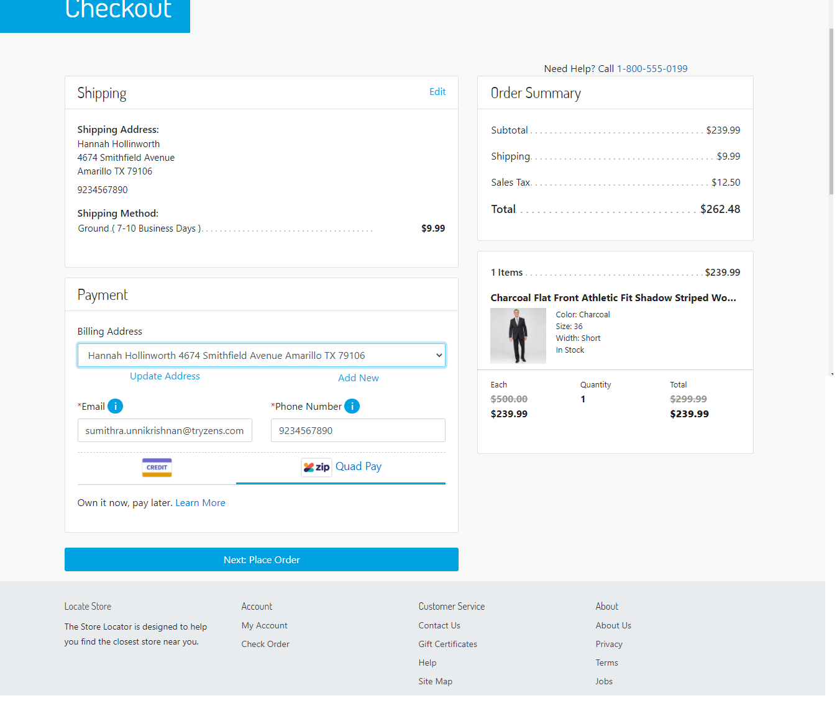

Enter an email and a phone number.

Below test phone and email can be used for testing:

|  |  |
| --- | --- |
| Phone Number | 9234567890 |
| Email | ziptest_12013814330@mailinator |

Choose QuadPay payment method.

Click “*Next: Place Order*”.

### View Payment Summary and Continue to QuadPay

On the payment summary step, the payment is “QuadPay” and there should be a button “*Continue to QuadPay*”.

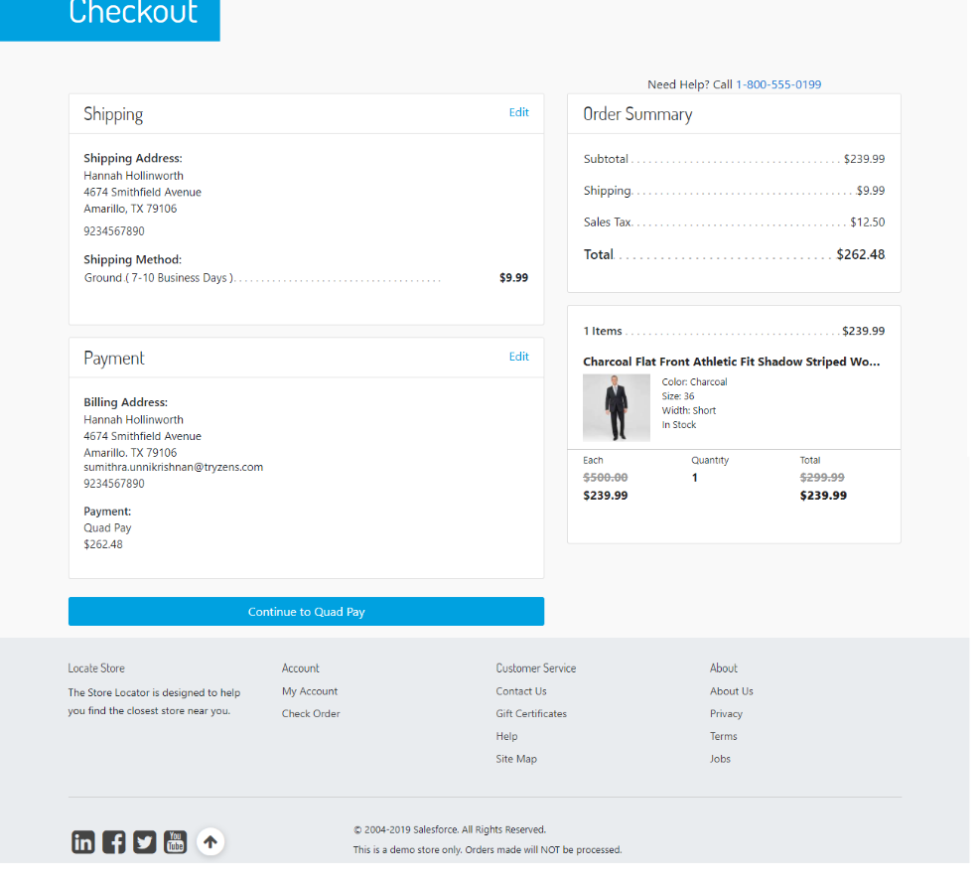

When the button is clicked, redirected to QuadPay page.

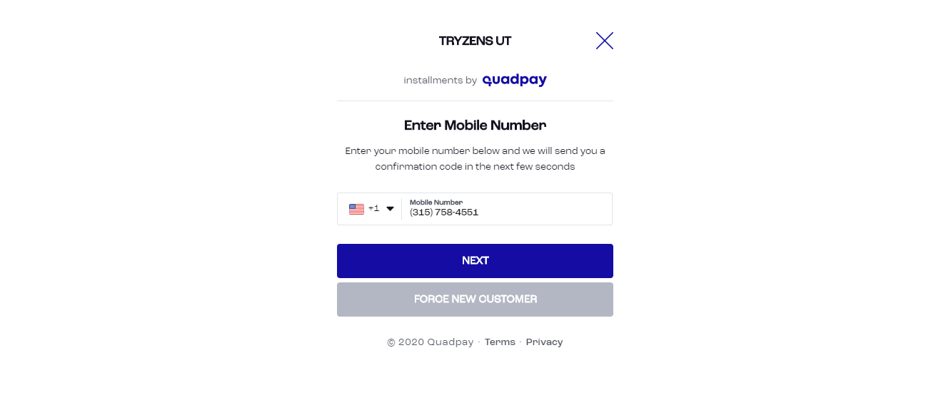

Enter any test US phone number. We used below number for testing:

(315) 758-4551

Click “FORCE NEW CUSTOMER”,

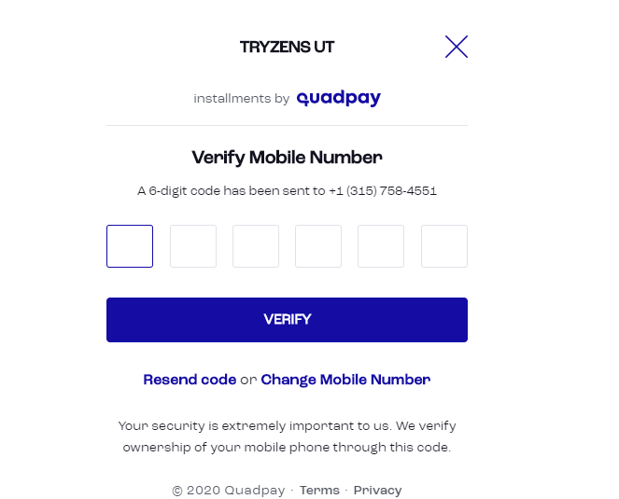

Enter the verification code received on the mobile number entered in the previous step.

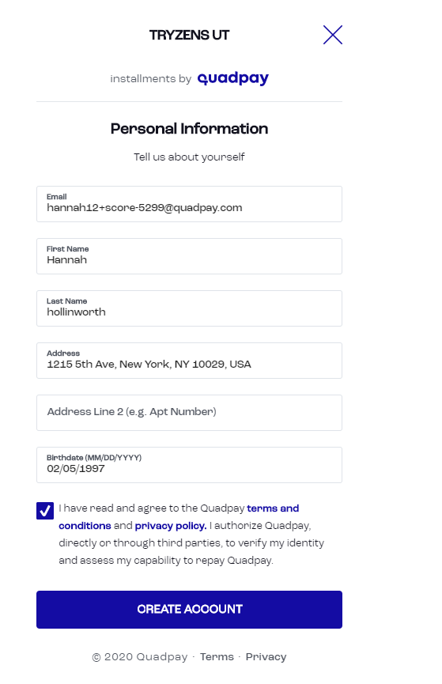

On the personal information screen enter, email address in **'+**[**score-299@quadpay.com**](mailto:score-299@quadpay.com)**'**pattern. **Score represents the application score starting from 200.** Lower score i.e., 200 will result in failed application. Please assign higher score for approved applications.

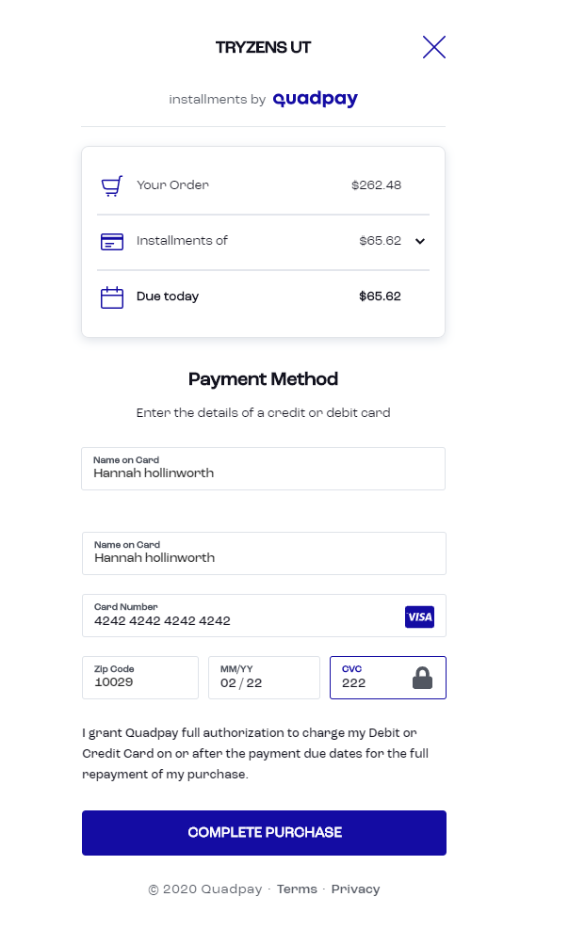

Enter personal details and click on Create account button to proceed to payment step. Enter test payment details and click on complete order to continue.

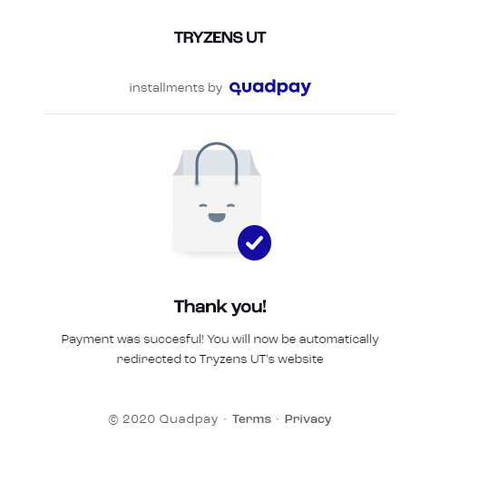

Payment successful page is displayed for a successful payment.

### Check Order Confirmation Page

The order has been approved by QuadPay. You should be redirected back to the “*Thank You*” confirmation page. You should see an additional “*Zip Receipt Number*” which has been generated by QuadPay. This receipt number is also sent with the confirmation email.

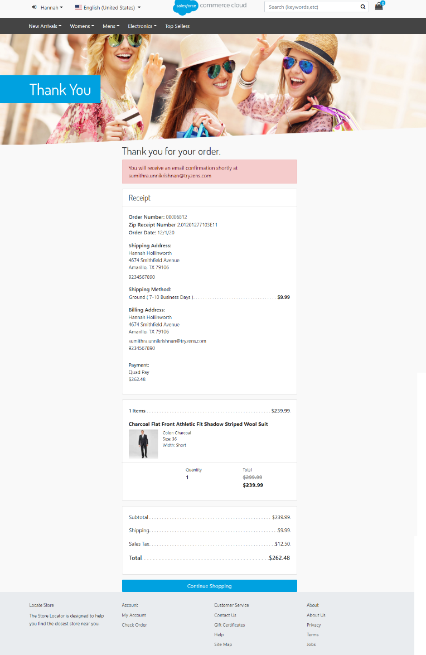

### Check Confirmation Email

The confirmation email sent should also contain QuadPay Receipt Number as shown below.

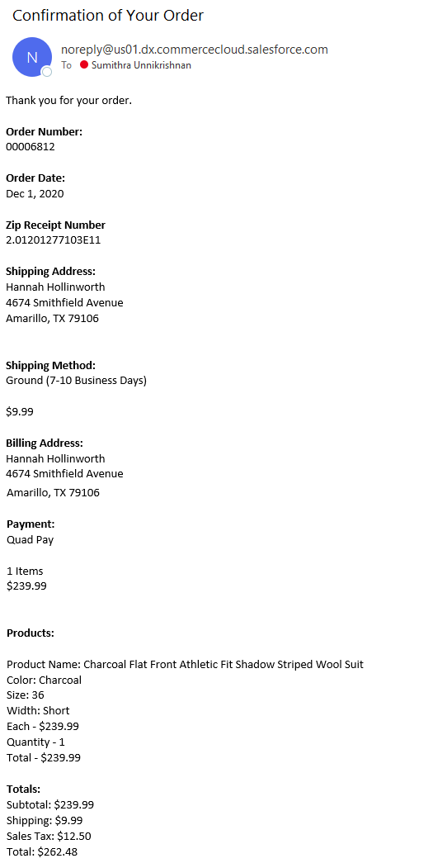

### Check Order in Business Manager

Last, we visit the Order in Business Manager. From “Merchant Tools”, please select “Orders”. Type the order number in the search box and click “Find”. Click on the order number.

The View Order screen appears, and we should be at the “General” tab. Here, you should see status “*Confirmed*” since we have enabled auto-capture in the beginning of the test.

Click on the “*Payment*” tab. There are couple of things we are looking for. Payment status should be “Paid”. The processor for the full payment should be “*Zip*”. In addition to that, QuadPay Email and QuadPay Phone contain the email and phone number from billing step during checkout. You should be seeing the QuadPay Receipt Number same as in the confirmation page and email. The QuadPay Charge ID is an identifier of the charge created when order has been approved. The “Is Automatic Capture” to confirm the charge has been automatically captured. At last, we are seeing “QuadPay Product” to hold the QuadPay product the customer placed.

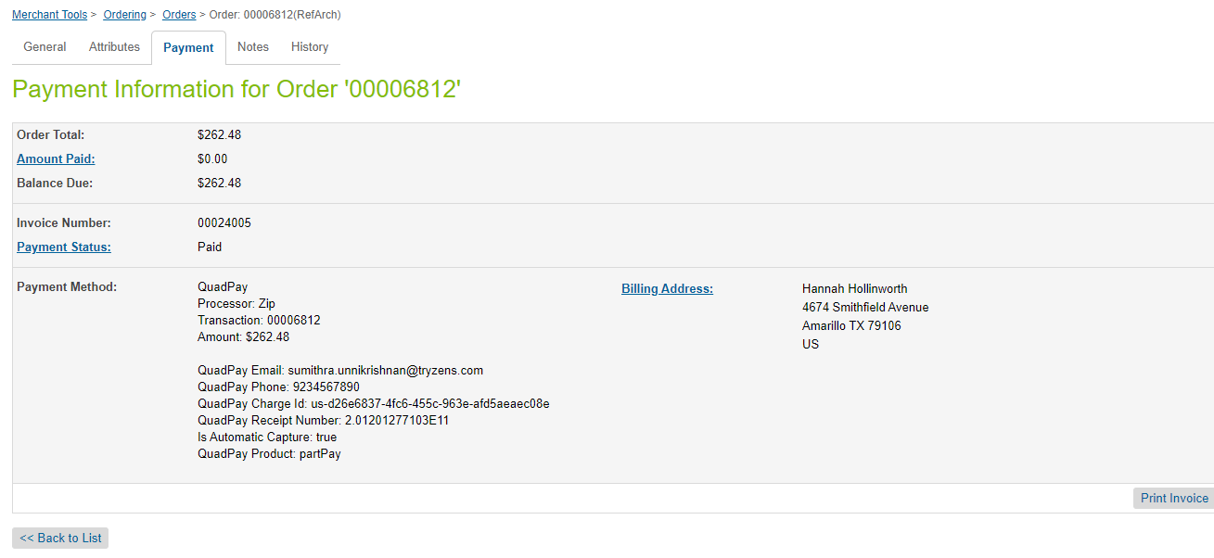

### Visit Zip Merchant Dashboard to confirm Order

As an additional, optional step, we have visited the merchant dashboard to check for the approved order.

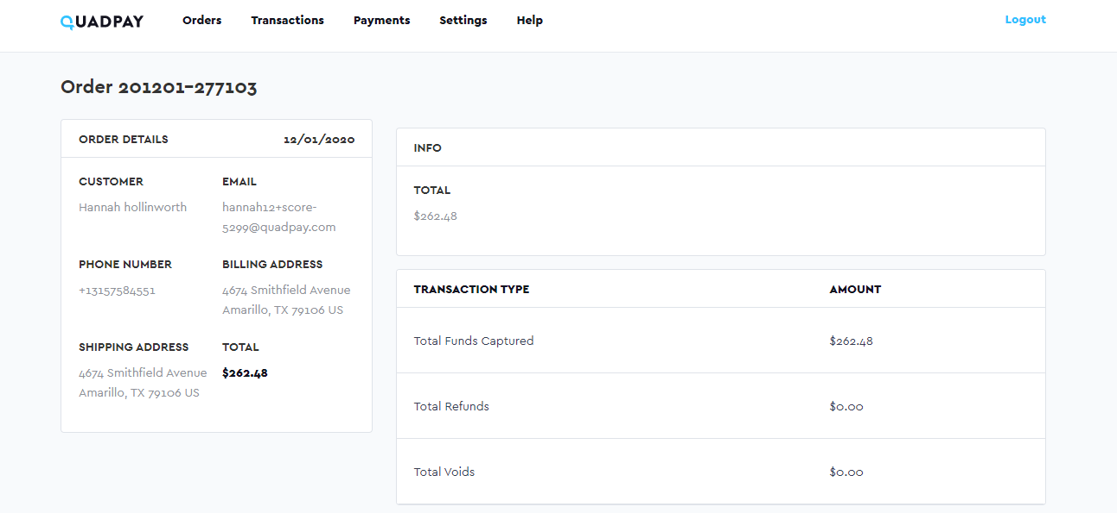

Checkout with PayFlex Standard Flow

We are going to use the global site “*RefArch*” to complete the test.

### Prerequisites

As a prerequisite to the test, we must enable auto-capture. Check out the screenshot below:

### Visit website and Choose Locale

Once the configuration is done in the Business Manager, you should visit the website. PayFlex is available for ZA region. For this test, we are using the “*English (South Africa)*” locale from the drop-down.



### Add Product

We have selected a simple product from a category “*Mens – Clothing – Suits*”. We have added 1 to cart.

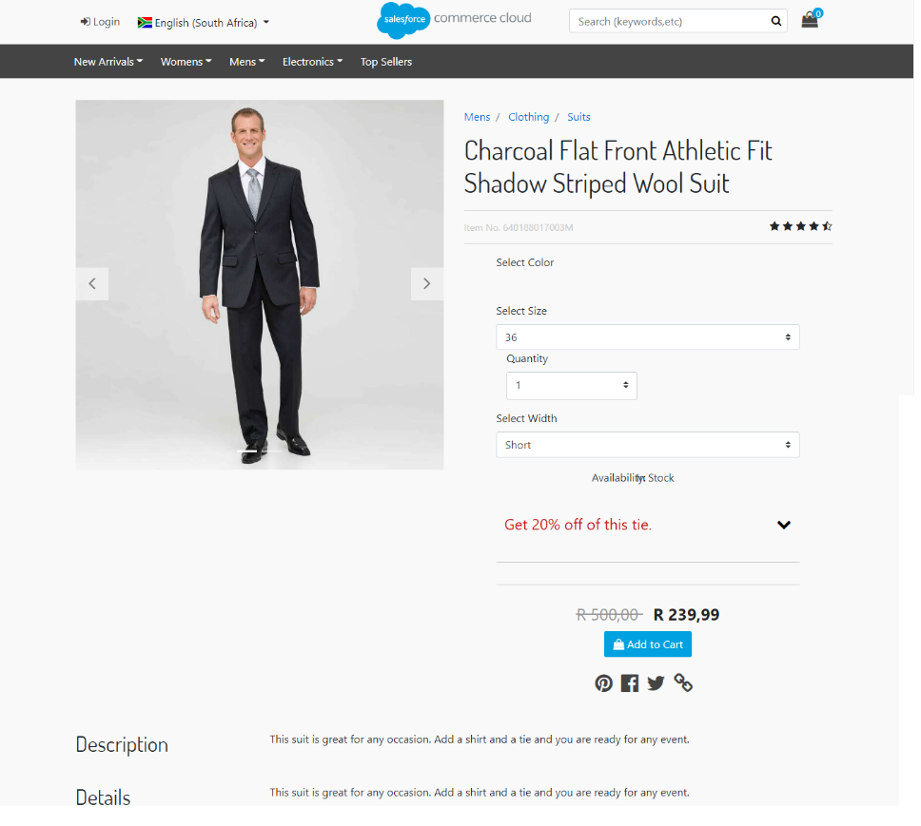

### Proceed to Checkout and Enter Shipping Information

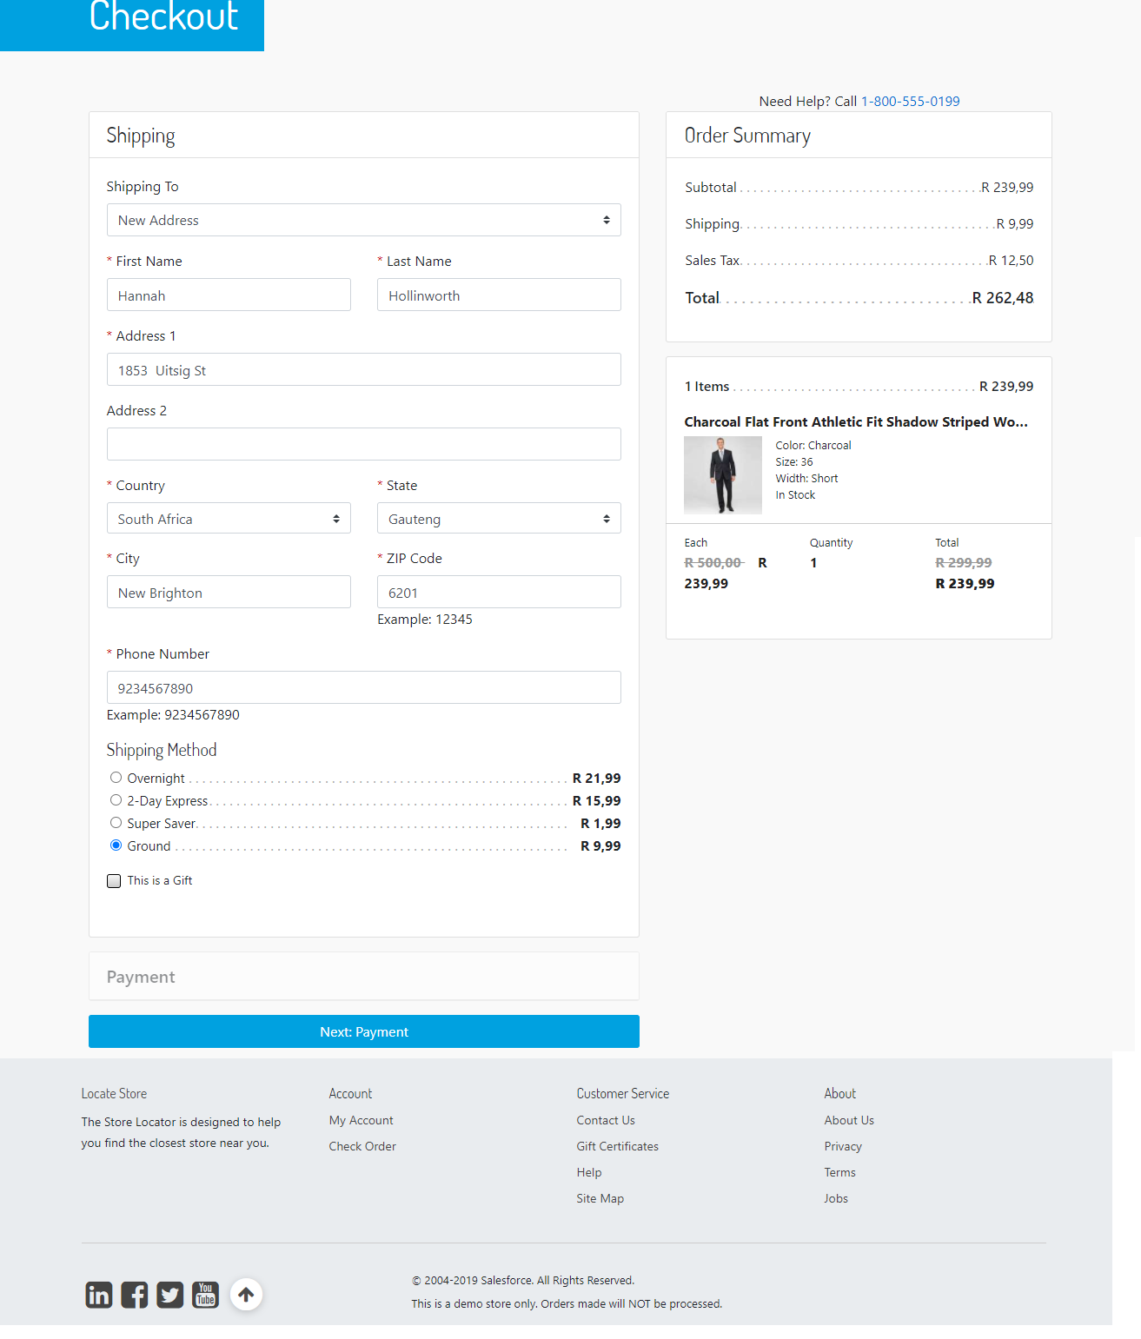

We used the following test address:

|  |  |
| --- | --- |
| First Name | Hannah |
| Last Name | Hollinworth |
| Address 1 | 1853 Uitsig St |
| Country | South Africa |
| State | Gauteng |
| City | New Brighton |
| Zip Code | 6201 |
| Phone Number | 9234567890 |

Any shipping method should work. For the test, we are using *Ground*.

When done, click “*Next: Payment*”.

### Enter Billing Information and Choose PayFlex as Payment Method

On the billing step, if everything has been configured correctly, PayFlex should appear as a payment method.

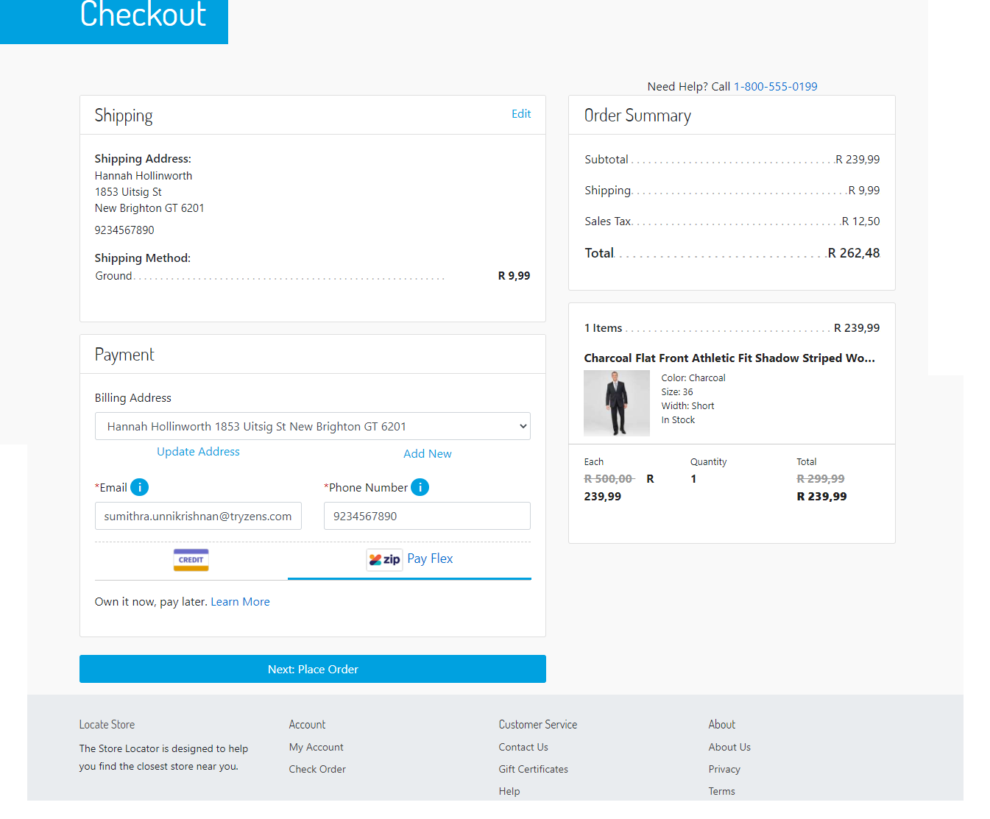

Enter an email and a phone number.

Below test phone and email can be used for testing:

|  |  |
| --- | --- |
| Phone Number | 9234567890 |
| Email | ziptest_12013814330@mailinator.com |

Choose PayFlex payment method.

Click “*Next: Place Order*”.

### View Payment Summary and Continue to PayFlex

On the payment summary step, the payment is “PayFlex” and there should be a button “*Continue to PayFlex*”.

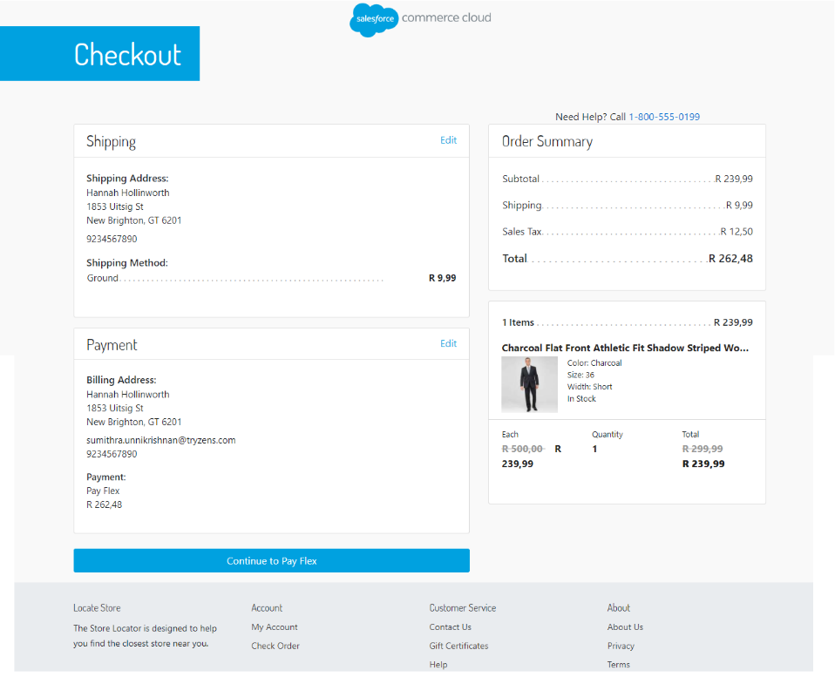

When the button is clicked, redirected to PayFlex page.

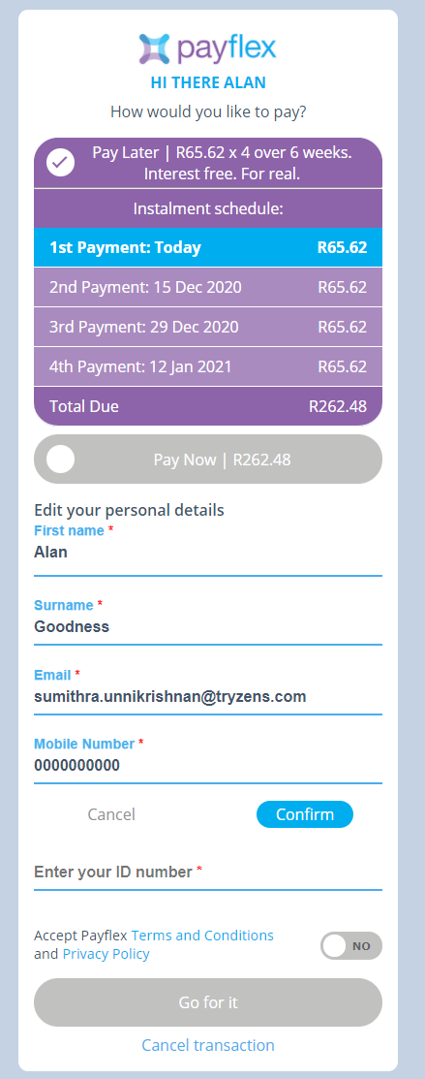

Select “Pay Now button” and enter email

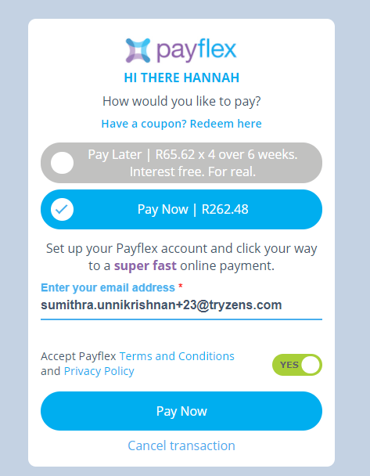

Click “Pay Now” button,

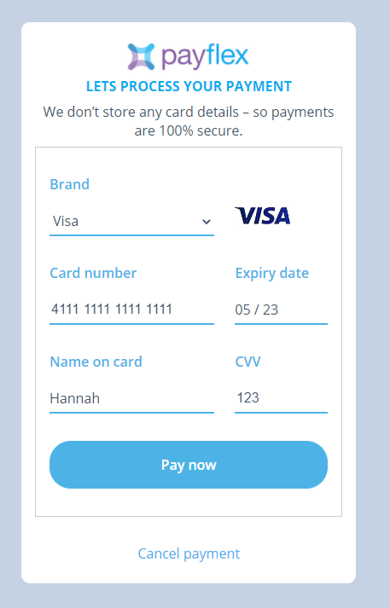

Click “Pay Now”,

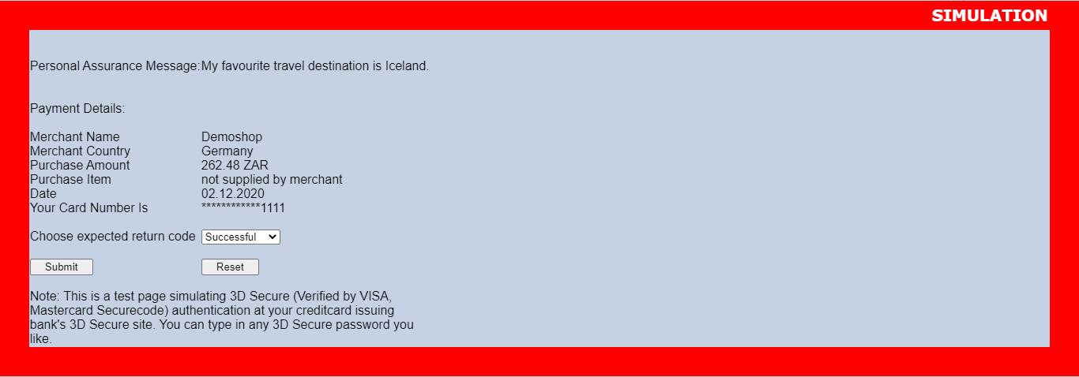

Click “Submit” button,

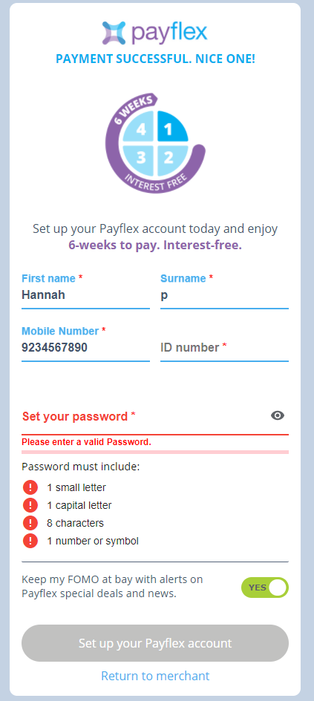

### Check Order Confirmation Page

The order has been approved by PayFlex. You should be redirected back to the “*Thank You*” confirmation page. You should see an additional “*Zip Receipt Number*” which has been generated by PayFlex. This receipt number is also sent with the confirmation email.

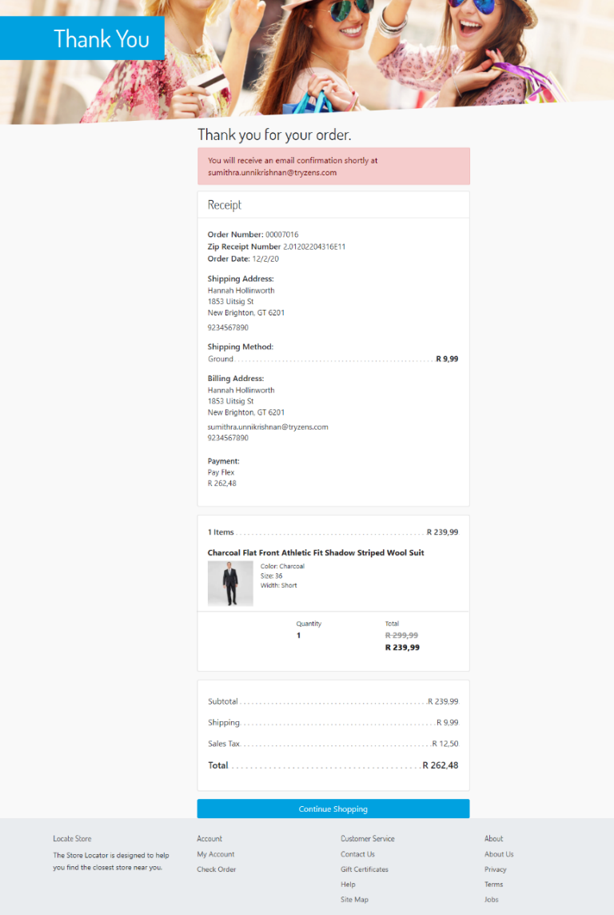

### Check Confirmation Email

The confirmation email sent should also contain PayFlex Receipt Number as shown below.

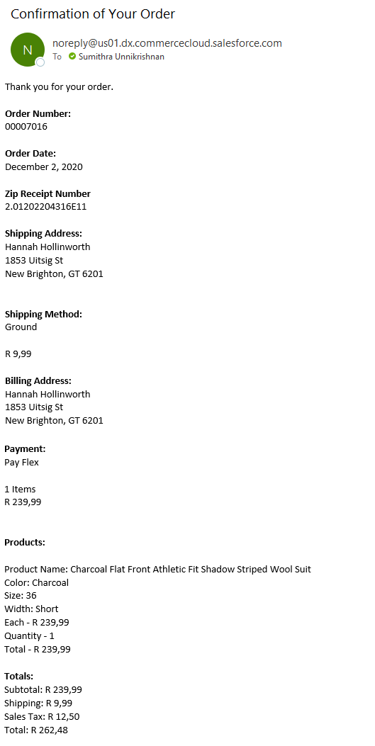

### Check Order in Business Manager

Last, we visit the Order in Business Manager. From “Merchant Tools”, please select “Orders”. Type the order number in the search box and click “Find”.

The View Order screen appears, and we should be at the “General” tab. Here, you should see status “*Confirmed*” since we have enabled auto-capture in the beginning of the test.

Click on the “*Payment*” tab. There are couple of things we are looking for. Payment status should be “Paid”. The processor for the full payment should be “*Zip*”. In addition to that, PayFlex Email and PayFlex Phone contain the email and phone number from billing step during checkout. You should be seeing the PayFlex Receipt Number same as in the confirmation page and email. The PayFlex Charge ID is an identifier of the charge created when order has been approved. The “Is Automatic Capture” to confirm the charge has been automatically captured.

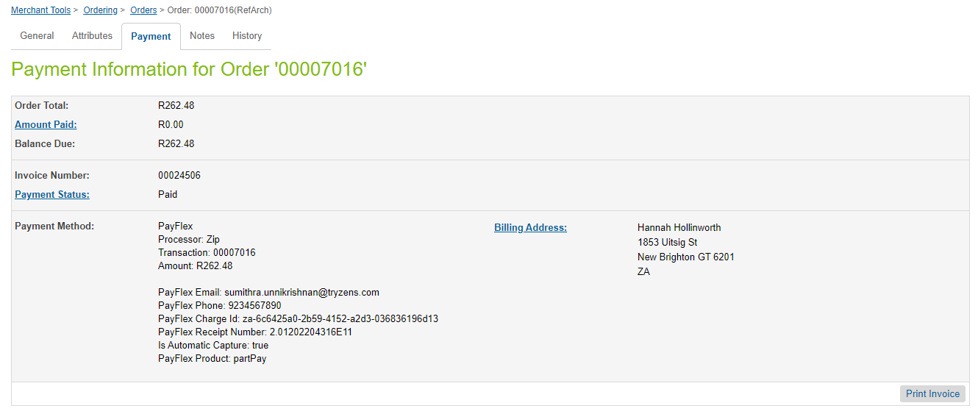

# Operations, Maintenance

## Data Storage

### Zip Tokens

Zip tokens are stored within Order system objects for the period of their existence. This is true if tokenization is enabled (by the merchant).

Zip tokens are also stored within a customer’s wallet if the customer has requested to save Zip as a payment method during checkout. Such a token is removed only when the customer removes the payment instrument from within their My Account area. This feature is only available for Zip Australian region.

## Availability

In case of problems with the connection to Zip Payments please contact the Zip, Payments support department.

Please supply as much information as possible (Merchant account, time, order number, Zip Payments reference etc.). Also, please check the log file mentioned above.

## Support

In case of problems with the integration, missing features, etc. please contact the Zip Payments support department or your zipMoney account manager.

# User Guide

This section of the integration guide describes how merchants can configure the features of this integration.

## Business Manager

### Configure Zip Payments Processor

#### Enable/Disable Zip

To configure this feature, the merchant needs to use the setting located in “Merchant Tools – Custom Preferences – Zip – Enable Zip” for Zip payment.

#### Enable/Disable PayFlex

To configure this feature, the merchant needs to use the setting located in “Merchant Tools – Custom Preferences – PayFlex – Enable PayFlex” for PayFlex payment.

#### Enable/Disable QuadPay

To configure this feature, the merchant needs to use the setting located in “Merchant Tools – Custom Preferences – QuadPay – Enable QuadPay” for QuadPay payment.

#### Activate Production Mode

To configure this feature, the merchant needs to use the setting located in “Merchant Tools – Custom Preferences – Zip – Zip API Mode Production” for Zip payment.

(when the merchant is ready for production, the API Key also needs to be updated.)

To configure this feature, the merchant needs to use the setting located in “Merchant Tools – Custom Preferences – PayFlex – PayFlex API Mode Production” for PayFlex payment.

(when the merchant is ready for production, the API Key also needs to be updated.)

To configure this feature, the merchant needs to use the setting located in “Merchant Tools – Custom Preferences – QuadPay – QuadPay API Mode Production” for QuadPay payment.

(when the merchant is ready for production, the API Key also needs to be updated.)

#### Set API Key

To configure this feature, the merchant needs to use the setting located in “Merchant Tools – Custom Preferences – Zip – Zip API Mode Production” for Zip payment.

To configure this feature, the merchant needs to use the setting located in “Merchant Tools – Custom Preferences – PayFlex – PayFlex API Mode Production” for PayFlex payment.

To configure this feature, the merchant needs to use the setting located in “Merchant Tools – Custom Preferences – QuadPay – QuadPay API Mode Production” for QuadPay payment.

#### Enable/Disable Automatic Capture

To configure this feature, the merchant needs to use the setting located in “Merchant Tools – Custom Preferences – Zip – Automatic Capture”.

#### Enable/Disable Zip Tokenization

To configure this feature, the merchant needs to use the setting located in “Merchant Tools – Custom Preferences – Zip – Zip Tokenization”. This feature is only available for Zip Australian region.

### Configure Zip Payment Method

#### Update Payment Method Logo

The Zip payment method logo can be updated.

The setting is in “Merchant Tools – Ordering – Payment Methods”. On the payment method screen, choose “Zip”. Then, use the “Image” setting and choose Zip logo from int_zippay\cartridge\static\default\images or upload a new logo.

### Configure PayFlex Payment Method

The PayFlex payment method logo can be updated.

The setting is in “Merchant Tools – Ordering – Payment Methods”. On the payment method screen, choose “PayFlex”. Then, use the “Image” setting and choose PayFlex logo from int_zippay\cartridge\static\default\images or upload a new logo.

### Configure QuadPay Payment Method

The QuadPay payment method logo can be updated.

The setting is in “Merchant Tools – Ordering – Payment Methods”. On the payment method screen, choose “QuadPay”. Then, use the “Image” setting and choose QuadPay logo from int_zippay\cartridge\static\default\images or upload a new logo.

#### Allowed Countries

The setting is in “Merchant Tools – Ordering – Payment Methods”. On the payment method screen, choose “Zip” and then use the “Countries” setting to configure allowed countries. Zip payment method will only be available for those countries you select.

#### Min/Max range for each currency

The setting is in “Merchant Tools – Ordering – Payment Methods”. On the payment method screen, choose “Zip” and then use the “Min/Max Payment Ranges” setting for each currency.

### Configure Zip Checkout

#### Configure Zip Payment Declined Message

The message appearing on payment stage when Zip payment is declined is configurable via a content asset: “zip-declined”.

#### Configure Zip Referral Order Error Message

The message appearing on payment stage when the Zip referral order is cancelled. It is configurable via a content asset: “zip-referral-error”.

### Configure Zip API Client

#### Configure Retries in case of General Errors

In case of general errors, the Zip API Client will retry requests according to configuration values specified in the Zip Service Profile. To access those configuration values, navigate to “Administration – Operations – Services” and then select “Profiles” tab. Choose the “zip.http.service” profile.

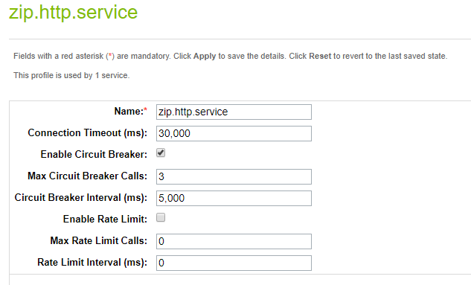

The **Max Circuit Breaker Calls** determine the number of attempts the Service is going to make in case of general errors. The **Circuit Breaker Interval** determine the interval in which those attempts will be made.

General errors are:

* Issues at initial connection.
  + Unknown host
  + Connection timeout
  + Connection refused
* Protocol-specific errors, such as HTTP 500 - internal server error or HTTP 503 - service unavailable.
* Exceptions explicitly thrown as part of the service call

# Known Issues

None.

# Release History

|  |  |  |
| --- | --- | --- |
| **Version** | **Date** | **Changes** |
| 19.1.0 |  | Initial release |
| 21.1.0 | 30-Nov-2020 | 1. Added new payment methods - QuadPay for US regions and Payflex for South Africa region 2. Removed Zip footer content asset and logo 3. Moved common functionality to a core cartridge, int_zippay |
| 21.1.1 | 24-May-2021 | Updated meta file to update default value of site preference ‘zipLightbox’ to false |